Our Games
Our Code

Code of Best Practice in Youth Sport
when working with underage players
Contents

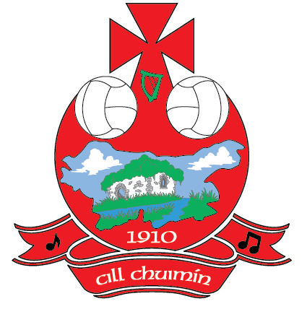
Our Games Our Code
Code of Best Practice in Youth Sport when working with underage players

The publication by the Gaelic Athletic Association, Ladies Gaelic Football Association, the Camogie Association, GAA Handball Ireland and the Rounders Council of Ireland of Our Games – Our Code, the Joint Code of Best Practice in Youth Sport, is indeed a momentous occasion for all who work with underage players and vulnerable adults in our respective Associations.

This Code brings together the collective good practice experiences of our Associations while also recognising the legislative, organisational and statutory guidance that governs our work with young people and children. Our Games – Our Code will assist us in supporting and directing our members and all units of our Associations in our work with underage teams in a coordinated and developmental manner.

Our Associations, in common with others who work with young people and children on a daily basis, will continue to abide by and integrate child welfare legislation and statutory guidance into our work, regardless of the jurisdiction in which we operate. In upholding this principle, the welfare of the child shall always be our paramount consideration, whether it is on the playing fields, in the training of our underage players, the recruitment of our coaches or the many other developmental and social opportunities that we offer our underage players on a daily and weekly basis.

If the local community is a bedrock of our Association so also are our underage players, many of whom
will play our games from childhood to adulthood and will hopefully progress in later years to coaching and mentoring roles, more often than not in the one Club.

Our underage players will spend some of the most enjoyable days of their lives playing our games and socialising with their friends. Whether attending or playing GAA matches, playing Ladies Football or Camogie, or participating in Rounders or Handball activities, they will do so during some of the most important developmental years of their lives. Our role and our responsibility is to ensure that they benefit from and participate in our Gaelic Games in a safe and enjoyable environment and where our Games are conducted in a spirit of fair play where everyone working on our behalf emphasises respect, equality, safety and non discrimination in all aspects of our work with children and young people.

Agus an Cód Dea Chleachtais seo i bhfeidhm anois agus ba mhaith linn an Cód seo a fheiceáil forbartha i measc chuile dhuine a imríonn agus a ghlacann páirt inár gCluichí Gaelacha. Mol an Óige agus tiocfaidh sí.

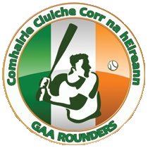
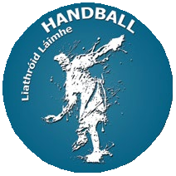
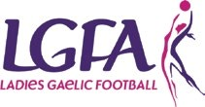

Section 2
Child Protection and Welfare Statement

Our Games – Our Code is the new Code of Best Practice in Youth Sport agreed by the Gaelic Athletic Association, Ladies Gaelic Football Association, the Camogie Association, GAA Handball Ireland and the Rounders Council of Ireland. This Code will direct our members and all units of our Associations in our work with underage teams.

Our Associations are committed to creating and maintaining the safest possible environment for all young people who participate in our Gaelic Games and activities. We shall take all practicable steps to protect them from discernable forms of abuse, from harm, discrimination or degrading treatment and shall respect their rights, wishes and feelings.

WE DO THIS BY;

• Recognising that all children have the right to be protected from harm.

• Ensuring that all our coaches and volunteers are carefully recruited and selected in accordance with our own guidelines and relevant legislative requirements and that they accept responsibility for ensuring the wellbeing of children in their care.
• Responding swiftly and appropriately to any allegations or concerns so as to protect the welfare of children who participate in our games and related activities.
• Appointing Children’s Officers in each of our Clubs and at County Board level.

• Appointing a National Children’s Officer to oversee the implementation of good child protection
and welfare practices within our Associations.

• Appointing a Designated Officer in each Club and County who will liaise with the statutory
authorities as appropriate.

• Appointing a National Designated Officer to assist, advise and oversee the processing of child
protection and welfare matters.

• Providing parents and children with the opportunity to voice their concerns.

• Ensuring that all allegations of abuse of young people are confidentially dealt with in accordance
the Association Guidelines and relevant legislation.

• Reviewing the effectiveness of our Child Protection and Welfare procedures and related policies on
an on-going basis.

• Ensuring that members, coaches, team mentors, administrators, parents/guardians and spectators sign up to and adhere to our Code of Behaviour.
• Promoting the Give Respect - Get Respect initiative at all levels within our Associations.
Section 3
Code of Behaviour
When working with underage players

This Code of Behaviour is one section, albeit a vital section, of the Code of Best Practice in Youth Sport, Our Games - Our Code.

The Code of Behaviour addresses the minimum appropriate levels of behaviour, practice and conduct required from our Young Players, Coaches, Supporters, Parents/Guardians, Referees and Clubs.

The Gaelic Athletic Association, the Camogie Association, Ladies Gaelic Football Association, GAA Handball Ireland and the Rounders Council of Ireland have endorsed this Code so that it may act as a guidance for those who promote and deliver our Gaelic Games and assist them in complying with the highest possible standards in our work with children and young people.

Everyone involved in our sports and in our activities should accept the roles and responsibilities that they undertake as we commit ourselves to maintaining an enjoyable and safe environment for all. The safeguarding of our members will always be a key priority as we recognise that the welfare of the child is of paramount importance in our work.

This Code should be used in tandem with the overall Code of Best Practice in Youth Sport, Our Games – Our Code, where roles and responsibilities are outlined in greater detail. It is recommended that Coaches, Parents/Guardians and Players sign this Code of Behaviour and present the signed document, as a commitment of its implementation, to their Club Children’s Officer.

Our aim is to ensure that young people and children who play our games receive the best possible care, attention and protection while participating in our Gaelic Games.

Should a breach of the Code be alleged, or when people may refuse to adhere to the contents of the Code, certain actions may be deemed necessary and appropriate so as to protect the integrity of our work with children and young people and also to ensure that they receive the best possible care, attention and protection while participating in our Games.
Alleged breaches of this Code may therefore be enquired into, regardless of where or when they occur, in accordance with the guidance contained elsewhere in this Code and with particular reference to
the accompanying publication, ‘Our Games Our Code: Dealing with Alleged Breaches of the Code of Best Practice in Youth Sport.’ Following any such enquiry, and where deemed necessary, sanctions or disciplinary action may be taken against those who have been proven to have breached the Code of Best Practice in Youth Sport.

This Code applies to all underage players and those who assist them in the preparation and playing of our games, regardless of competition or age group. Clubs, County Boards and Games Officials who are responsible for organising our games at all levels are obliged to implement this Code in the preparation of their teams and players for all competitions and at all other levels including Club blitzes and competitions, County development squads and Inter -County games.

It is our wish that this Code is developed, promoted and implemented as an initiative that encourages fair play, respect, equality, safety and non discrimination in all aspects of our work with children and young people.

Young Players

Young Players can benefit greatly from sports in terms of personal development and enjoyment. Our players are encouraged to realise that as a result of their participation in our Gaelic Games that they also have a responsibility to treat other players and officials with fairness and respect. With rights there will always be responsibilities.

Young Players, and those who work with them in our Associations are required to ‘sign up’ and abide by this Code of Behaviour and to any other policies or codes in your Club or National Governing Body.

YOUNG PLAYERS SHOULD BE ENTITLED TO:

• Be safe and feel safe.

• Have fun and experience a sense of enjoyment and fulfilment.

• Be treated with respect, dignity and sensitivity.

• Comment and make suggestions in a constructive manner.

• Be afforded appropriate confidentiality.

• Participate in games and competitions at levels with which they feel comfortable.

• Make their concerns known and have them dealt with in an appropriate manner.

• Be protected from abuse.

• Be listened to.

YOUNG PLAYERS SHOULD ALWAYS

• Play fairly, do their best and enjoy themselves.

• Respect fellow team members regardless of ability, cultural or ethnic origin, gender, sexual orientation or religious beliefs.
• Support fellow team members regardless of whether they do well or not.

• Represent their team, their Club and their family with pride and dignity.

• Respect all Coaches, Officials and their opponents.

• Be gracious in defeat and modest in victory.

• Shake hands before and after a game as part of the Give Respect Get Respect initiative, irrespective of the result.
• Inform their Coach/Mentor/Manager in advance if they are unavailable for training and games.

• Take due care of Club equipment.

• Know that it is acceptable to talk to the Club Children’s Officer with any concerns or questions they
may have.

• Adhere to acceptable standards of behaviour and their Club’s Code of Discipline.

• Tell somebody else if they or others have been harmed in any way.
YOUNG PLAYERS SHOULD ENGAGE IN GOOD PRACTICE:

• Never cheat – always play by the rules.

• Never shout at or argue with a game’s official, with their Coach, their team mates or opponents and
should never use violence.

• Never use unfair or Bullying tactics to gain advantage or isolate other players.

• Never spread rumours.

• Never tell lies about adults or other young people.

• Never play or train if they feel unwell or are injured.

• Never use unacceptable language or racial and/or sectarian references to an opponent, a fellow
player or official by words, deeds or gesture.

• Never consume non-prescribed drugs or performance enhancing supplements
Coaches, Mentors and Trainers

All Coaches, Mentors and Trainers (referred to hereafter as Coaches) should ensure that young people and children benefit significantly from our games by promoting a positive, healthy and participatory approach in our work with underage players. In developing the skills levels of every player, Coaches should always encourage enjoyment and fun while ensuring meaningful participation in our games and activities. Coaches should always remember that they are role models for the players in their care.

RECRUITMENT OF COACHES

All Coaches working with young people and children are required to be suitable for their chosen role(s), and should be appropriately trained, qualified and supported to fulfil such roles. All persons working or volunteering for such roles are required to undertake agreed vetting and background Police checks within the jurisdiction in which they work and to attend coaching and training courses relevant to their roles. All such Coaches must attend relevant child welfare and protection training as provided or instructed by their Governing body and must also complete a basic coach education qualification.

COACHES SHOULD MAINTAIN A CHILD CENTRED APPROACH

• Respect the rights, dignity and worth of every person.

• Treat each person equally regardless of age, gender, ability, ethnic origin, cultural background or religion.
• Be positive during coaching sessions, games and other activities so that underage players always leave with a sense of achievement and an increased level of self-esteem.
• Recognise the development needs and capacity of all underage players, regardless of their ability, by emphasising participation for all while avoiding excessive training and competition. Skills development and personal satisfaction should have priority over competition when working with underage players.
• Develop an understanding of relevant coaching methods and ensure that they have the appropriate level of coaching accreditation.
• Do not equate losing with failure and do not develop a preoccupation with medals and trophies.
The level of improvement made by underage players is the best indicator of effective coaching.

COACHES SHOULD LEAD BY EXAMPLE

• Never use foul language or provocative language/gestures to a player, opponent or match official.

• Only enter the field of play with the Referee’s permission.

• Do not question a Referee’s decisions or integrity.

• Encourage players to respect and accept the judgement of match officials.

• Promote Fair Play and encourage all players and fellow officials to always play by the rules of the
game.

• Do not encourage or threaten a player by deed or gesture to act in any unacceptable manner
towards an opponent, fellow player or official.
• Promote the RESPECT campaign amongst your players, fellow coaches, parents and supporters.

• Do not smoke while working with underage players.

• Do not consume alcohol or non prescribed drugs immediately prior to or while underage players are in your care.
• Encourage parents to become involved in your team and Club activities wherever possible.

CONDUCT OF COACHES WHEN WORKING WITH YOUNG PEOPLE

• Develop an appropriate working relationship with children based on mutual trust and respect.

• Challenge Bullying in any form whether physical or emotional. Bullying is not acceptable behaviour
be it from a young person, coach, parent/guardian, spectator or match official.

• Don’t shout at or lecture players or reprimand/ridicule them when they make a mistake. Children learn best through trial and error. Children and young people should not be afraid to risk error so as to learn.
• The use of any form of physical punishment is prohibited as is any form of physical response to misbehaviour, unless it is by way of restraint.
• Avoid incidents of horse play or role play or telling jokes etc. that could be misinterpreted.

• Never undertake any form of therapy or hypnosis, in the training of children.

• Never encourage players to consume non-prescribed drugs or take performance enhancing supplements.

AVOID COMPROMISING YOUR ROLE AS A COACH

Some activities may require coaches to come into physical contact with underage players in the course of their duties. However, coaches should;
• Avoid taking coaching sessions on your own.

• Only deliver one to one coaching, if deemed necessary, within a group setting.

• Avoid unnecessary physical contact with an underage player and never engage in inappropriate touching of a player.
• Be aware that any necessary contact should be determined by the age and development of the player and should only take place with the permission and understanding of the player and in an open environment in the context of developing a player’s skills and abilities.

BEST PRACTICE

• Ensure that all of your players are suitably and safely attired to play their chosen sport. e.g. helmets
(Hurling and Camogie), goggles (Handball), shin guards, gum shields (Football).

• As a coach always be punctual and properly attired.

• Be accompanied by at least one other adult at coaching sessions, games and in underage team dressing rooms.
• Set realistic – stretching but achievable – performance goals for your players and teams.

• Keep a record of attendance at training and at games by both players and coaches.
• Rotate the team captaincy and the method used for selecting teams so that the same children are not always selected to the exclusion of others.
• Keep a record of any injuries and actions subsequently taken. Ensure that another official/referee/ team mentor is present when a player is being attended to and can corroborate the relevant details.
• Make adequate provision for First Aid services.

• Do not encourage or permit players to play while injured.

• Be aware of any special medical or dietary requirements of players as indicated on the medical consent/registration forms or as informed by parents/guardians.
• Ensure that all dressing rooms and the general areas that are occupied by your players and other Club personnel, prior to, during or immediately following the completion of any match are kept clean and are not damaged in any way.
• Be willing to keep the necessary and emergency medication of players in a safe and accessible place in accordance with the wishes and permission of the parents/guardians.
• Do not administer medication or medical aid unless you are willing to do so and have received the necessary training to administer such aid.
• Use mobile phones, if deemed appropriate, only via a group text or email system for communicating with the parents/guardians of players. Any exception to this form of group texting can only be proceeded with following permission from parents/guardians.
• Do not engage in communications with underage players via social network sites.

• Encourage parents/guardians to play an active role in organising and assisting various activities for your teams and your Club.
• If it is necessary to transport a child/young person in your car, ensure that they are seated in a rear seat with seat belts securely fastened and that all drivers are adequately insured.
• With the exception of their own child a coach should not transport a child alone, except in emergency or exceptional circumstances.
Parents/Guardians

Parents/Guardians have an influential role to play in assisting and encouraging their children to fully
participate in Gaelic Games, whether by playing our games or attending training or coaching sessions.

In common with Coaches and Club personnel the Parents/Guardians of underage players should act as role models for their children as they participate in Gaelic Games.

PARENTS/GUARDIANS SHOULD ENCOURAGE THEIR CHILD TO:

• Always play by the rules.

• Improve their skills levels.

• Appreciate everybody on their team, regardless of ability.

• Maintain a balanced and healthy lifestyle with regard to exercise, food, rest and play. Advice may
be sought if necessary from Club officials on this issue.

PARENTS/GUARDIANS SHOULD LEAD BY EXAMPLE:

• Adopt a positive attitude to their children’s participation in our games.

• Respect officials’ decisions and encourage children to do likewise.

• Do not exert undue pressure on your child.

• Never admonish your own child or any other child for their standard of play.

• Be realistic in their expectations.

• Show approval for effort, not just results.

• Avoid asking a child or young person, ‘How much did you score today’ or ‘What did you win by’ or
‘What did you lose by.’ Ask them ‘Did they enjoy themselves.’

• Never embarrass a child or use sarcastic remarks towards a player.

• Applaud good play from all teams.

• Do not criticise playing performances. Identify how improvements may be made.

• Do not seek to unfairly affect a game or player.

• Do not enter the field of play unless specifically invited to do so by an official in charge.

PARENTS/GUARDIANS SHOULD:

• Complete and return the registration/permission and medical consent forms for their child’s participation in the Club.
• Inform the Coaches, and any other relevant Club personnel, of any changes in their child’s medical or dietary requirements prior to coaching sessions, games or other activities.
• Ensure that their child punctually attends coaching sessions/games or other activities.

• Provide their child with adequate clothing and equipment as may be required for the playing of our games including for example helmets, shin guards, gum shields etc.
• Ensure that the nutrition/hydration and hygiene needs of their child are met.
• Never encourage your child(ren) to consume non-prescribed drugs or take performance enhancing supplements.
• Listen to what their child may have to say.

• Show approval whether the team wins, loses or draws a game.

• Never attempt to meet their own needs and aspirations for success and achievement through their children’s participation in games.

PARENTS/GUARDIANS SHOULD ASSIST THEIR CLUB BY:

• Showing appreciation to volunteers, coaches and Club officials.

• Attending training and games on a regular basis.

• Assisting in the organising of Club activities and events as requested.

• Respecting the rights, dignity and worth of every person and by treating each one equally regardless of age, gender, ability, ethnic origin, cultural background or religion.
• Not entering team dressing rooms unless deemed necessary by the team coach (es) so as to protect the privacy of other underage players.

PARENTS/GUARDIANS HAVE THE RIGHT TO:

• Know their child is safe and to make a complaint if they believe that their child’s safety is in any way compromised.
• Be informed of problems/concerns relating to their child.

• Be informed if their child gets injured.

• Complain if they have concerns about the standard of coaching.

• Have a say in relation to decisions being made within the Club.
Supporters

Young Players are eager to enjoy and benefit from the support they receive from parents, guardians, friends and other members of the Club who attend our games as spectators and supporters. Active, loyal and well behaved supporters are always welcome to attend and support our games but should be aware that their conduct will reflect upon the team, players and Clubs that they support and represent.

Fellow supporters have a responsibility to ensure that all spectators conduct themselves in an acceptable and well behaved manner at all times, when attending our games and competitions. Unacceptable conduct by supporters should be reported to stadium stewards or officials in charge.

Supporters should realise and consider that Young Players are encouraged to participate in Gaelic Games so that they may enjoy themselves while also improving their skills levels.

SUPPORTERS ADD TO THE ENJOYMENT OF OUR GAMES BY:

• Applauding good performance and efforts from your Club’s players and from your opponents,
regardless of the result.

• Condemning the use of violence in any form, be it by fellow spectators, coaches, officials or players.

• Encouraging players to participate according to the rules and the referees’ decisions.

• Demonstrating appropriate behaviour by not using foul language or harassing players, coaches or
officials.

• Not entering the field of play, before, during or after a game, unless specifically invited to do so by an official in charge.
• Respecting the decisions of all officials.

• Never ridiculing or scolding a player for making a mistake during games or competitions.

• Showing respect to your Club’s opponents. Without them there would be no games or competitions.
• Upholding the principles of FAIR PLAY and RESPECT for all.
Referees

Throughout this Code of Behaviour emphasis has been placed on the need to co-operate with and facilitate those who organise and deliver our games and activities. Referees are key people in the delivery of our games and should be respected and assisted in their roles.

Referees are conscious of the fact that they are instrumental in ensuring our games are played in a sporting manner in accordance with the rules of the game.

Players, Coaches, Mentors, Parents/Guardians and other Club personnel have a key role to play in the delivery of this aspect of our Gaelic Games particularly when working with underage players. The manner in which we accept the role, authority and decisions of a Referee will naturally be scrutinised very closely by our underage players.

IN THEIR CAPACITY AS REFEREES OF UNDERAGE GAMES WE EXPECT OUR REFEREES TO:

• Abide fully with the Code of Best Practice in Youth Sport: Our Games – Our Code

• Apply the playing rules on an impartial and consistent basis.

• Act with integrity and objectivity in all games.

• Communicate decisions to players and team officials in an effective and constructive manner.

• Deal with dissent firmly and fairly.

• Work as a team with other match officials.

• Maintain composure regardless of the circumstances.

• Avail of assessments and supports to improve performance.

• Uphold and implement the Give Respect – Get Respect initiative at all levels.

Players, Coaches, Supporters, Parents/Guardians and other Club personnel should recognise the pivotal role that Referees play in our underage games and should support them at all times when fulfilling their roles.
GIVE RESPECT - GET RESPECT

Give Respect – Get Respect is an awareness campaign that seeks to ensure that Gaelic Games are promoted and played in a positive, fair and enjoyable manner and where Players, Coaches, Spectators and Referees Give Respect – Get Respect from each other.

The RESPECT campaign applies at all levels and amongst all players regardless of age, competition or ability. The key participants in the Give Respect – Get Respect campaign are not just the Players themselves but Coaches, Clubs, Parents, Referees and Supporters.

The Give Respect – Get Respect initiative is supported by the GAA, Ladies Gaelic Football Association, the
Camogie Association, GAA Handball Ireland and the Rounders Council of Ireland.

THE RESPECT CAMPAIGN HIGHLIGHTS THE FOLLOWING GOOD PRACTICES:

• All players and coaches shake hands with their opponents and the referee before and after each game.
• Mark out a designated spectators’ area around the playing area.

• At relevant underage categories teams should strive to achieve the maximum participation of all players in accordance with agreed playing models.
• The host Club should welcome referees and opposing teams to all games.

• A merit award, based on sporting endeavour and fair play, shall be awarded to players and teams who have upheld the RESPECT principles.
• Adopt and implement the Code of Behaviour when working with underage players as the minimum level of agreement between the Club and players, coaches, parents, guardians and supporters at underage level.

• Organise half time exhibition games during Club and inter County League and Championship Games that promote the principles of the RESPECT campaign in association with Schools, other Clubs and Cumann na mBunscol.

RESPECT • RESPONSIBLE
• ENCOURAGING
• SUPPORTIVE
• POSITIVE
• ENABLING
• CONSIDERATE
• TOLERANT
The Club

Clubs that cater for underage players must do so with a child centred approach and philosophy that recognises that the welfare of the child is paramount while ensuring that each child is provided with developmental opportunities that are appropriate to their age and abilities.

Clubs must ensure that those chosen to work on their behalf with underage players have been selected following a thorough recruitment, selection, training and coaching procedure which includes relevant vetting in accordance with the jurisdiction requirements in which we operate.

Clubs must also provide those who work on our behalf with the necessary supports so as to enable them to fulfill their roles. Clubs will ensure that those chosen to work with children and young people are at all times competent and confident in their roles, have undertaken comprehensive recruitment procedures including vetting, have received relevant child welfare related training, as provided or instructed by their Governing Body, and must also have completed a basic coach education qualification.

Clubs must formally ratify the appointment of those that are chosen to act as underage mentors, coaches and managers. Such ratification of roles may take place at Club Executive level or by the Club Coiste na nÓg and should be subject to annual renewal. These appointments should not take place via election
or a vote of the membership but rather by recommendation from the relevant Committee following
consideration of suitably qualified individuals.

CLUBS SHOULD PROMOTE QUALITY PARTICIPATION BY:

• Adopting the Code of Behaviour as a basic level of agreement between the Club and their players, their coaches, parents/guardians and supporters.
• Leading by example and ensuring that a user friendly and child centred approach is adopted in our work with young people and that equal opportunities are available for all to participate in our games and activities, regardless of an individual’s ability.
• Developing effective procedures for responding to and recording all attendances, incidents,
accidents and injuries.

• Accessing relevant information on Alcohol and Substance Abuse Prevention Programmes and promoting relevant training in this area of health awareness for relevant Club personnel.
• Distributing information on Anti-Bullying strategies in our work with young people and by adopting and implementing an Anti-Bullying statement in the Club.
CLUBS SHOULD ENCOURAGE THE PARTICIPATION OF THEIR MEMBERS BY:

• Agreeing the role of each and every coach or mentor working with young people.

• Ensuring that relevant Child Protection Training is undertaken by all persons working in an official
capacity with children and young people in the Club.

• Adopting and implementing clearly defined recruitment and selection procedures when choosing
coaches and other relevant personnel to work with young people.

• When appointing mentors, coaches and managers of underage teams consideration should be given where possible to not appointing a parent of a child to such roles in the child’s team. Experience has shown that conflicts of interest may arise sometimes between a child and their parent or between other parents and the team mentors, coaches or managers who may act in such a capacity.

ENCOURAGE THE PARTICIPATION OF YOUNG PLAYERS BY:

• Ensuring that training schedules, playing rules, use of equipment and length of games are structured to facilitate greater participation by all Young Players, and are suitable to all age categories, and to the ability and maturity level of players.
• Not imposing responsibilities or roles on young people that may be inappropriate to their age.

• Respecting the rights, dignity and worth of all players and treating them equally regardless of their age, gender, ability, ethnic origin, cultural background or religion.
• Creating pathways for young people to participate in our games not just as players but by affording
them other developmental opportunities including training to become referees, coaches etc.

• Ensuring that when the team may travel away and stay overnight that separate sleeping facilities are provided for all adults and for young people. Similarly, for mixed groups, separate sleeping quarters for males and females shall be required.
• When a group consists of both males and females, that an adequate adult to member ratio of male and female coaches is present.

ENCOURAGE THE PARTICIPATION OF PARENTS/GUARDIANS BY:

• Encouraging parents/guardians to become members of their Club and to make themselves aware as to the running of juvenile games and activities and to the rules and codes that direct us in our work.
• Encouraging the participation of parents and guardians in all aspects of a Club’s activities and events and in the organising and delivery of our games.
• Welcoming all parents/guardians to attend the games and training sessions that relate to their children. Information relating to such events should be made known to them at all times.
• Informing parents/guardians as to the identity of their Children’s Officer. This person should be available to assist with any concerns or enquiries that parents/guardians may have regarding the welfare and safety of children and young people in the Club.
DEVELOP BEST PRACTICE IN CLUB STRUCTURES AND ADMINISTRATION BY:

• Ensuring that the Juvenile Section of the Club is structured in accordance with good practice
guidelines and that young people are afforded a role in decision making at an appropriate level.

• Ensuring that all Club members are aware as to their responsibilities to all children and young people.
• Appointing a Children’s Officer whose role shall include the monitoring of the child centred ethos
of the Club and compliance with any policies and guidelines as issued by the Club, by their National
Governing Bodies, or by statutory authorities and agencies in their jurisdiction.

• Appointing a Designated Liaison Person whose role shall include liaising with Statutory Authorities and the relevant Governing Body in relation to the reporting of allegations, concerns and/or suspicions of child abuse.
• Ensuring that all players are covered by their relevant Injury Scheme and that all premises etc. in use by your Club and players are equally covered for property/liability insurance as deemed necessary.
• Adopting procedures that facilitate the privacy and safety of all young people in the Club and that all such procedures are maintained and regularly reviewed so as to ensure that young people feel safe and are safe in the Club.
• Seeking the agreement of parents/guardians when their sons/daughters under 18 years of age are invited into adult squads. Boundaries of behaviour in adult groups are normally different from the boundaries that apply to underage teams and squads.
• Appointing a Code of Best Practice in Youth Sport Hearings Committee at Club level to hear complaints or allegations of breaches of the Code of Best Practice. The Committee of three people shall, through their representation, reflect the integrated nature of the Club, i.e. membership of the GAA, LGFA and Camogie. The functions of this Committee, plus all other procedures relating
to dealing with breaches of the Code, may be accessed in a complimentary publication, Our Games
Our Code: How to Deal with Alleged Breaches of the Code of Best Practice in Youth Sport.
Our Games – Our Code
Dealing with Alleged Breaches of the Code of Best
Practice in Youth Sport

Our Games – Our Code, the joint Code of Best Practice in Youth Sport (including the Code of Behaviour) outlines the minimum levels of behaviour that we require of those that are involved in underage games and activities. The Code applies equally to underage players, coaches, to parents and guardians, to our supporters, referees and officials. While the promotion of the Code may be seen as the responsibility
of the Children’s Officer ultimately it is everybody’s responsibility to ensure that the Code is fully
implemented.

Breaches of our Code will unfortunately occur from time to time, some minor and some of major consequences. This may happen as a result of carelessness, poor practice, lack of understanding or there may in some instances be deliberate or indeed calculated breaches of the Code.

Minor instances of poor practice may quite appropriately be dealt with at Club/County level by the Children’s Officer in an informal manner and by agreement. This could necessitate meeting with the person who may be responsible for the poor practice or the minor breach of the Code and resolving the issue amicably and by agreement. All such outcomes should be noted by the Club Children’s Officer. However, other alleged breaches of the Code may have to be dealt with in a more formal manner as outlined in the diagrams on pages 24 and 25.

A detailed publication titled Our Games Our Code: Dealing with Alleged Breaches of the Code of Best Practice in Youth Sport is available from the GAA, the Camogie Association, Ladies Gaelic Football Association, GAA Handball Ireland and the Rounders Council of Ireland or may be downloaded from their respective websites.
PROCESSING AN ALLEGED BREACH OF THE CODE AT CLUB LEVEL

Club Executive or Appointed Sub-Committee
Receives an Alleged Breach of the Code

Refer to Children’s Officer for Informal Action
Refer to Club or County Code of Best Practice Hearings Commitee

Refer to National Committe

Take No Further
Action

Deal with Alleged Breach Under Rule

Code of Best Practice & Code of Conduct Appeals Panel
Association Deals with Issue
in Accordance with Rule

PROCESSING AN ALLEGED BREACH OF THE CODE AT COUNTY LEVEL

Alleged Breach/Complaint
Received

Code of Best Practice in Youth Sport County Determining Comittee Determines how a complaint may be dealt with

Refer to Children’s Officer for Informal Action
Club or County Code of Best Practice Hearings Comittee

Refer to National Committe

Take No Further Action

Referred under rule to relevant Association Unit

Code of Best Practice & Code of Conduct Appeals Panel
Association Deals with Issue
in Accordance with Rule

CUMANN LÚTHCHLEAS GAEL The Gaelic Athletic Association

Páirc an Chrócaigh/Croke Park, Tel: +353 (0) 1 836 3222
Dublin 3 Email: info@gaa.ie http://www.gaa.ie

NN CAMÓGAÍOCHTA The Camogie Association
CUMA


Páirc an Chrócaigh/Croke Park, Tel: + 353 (0)1 865 8651
Dublin 3 Email: info@camogie.ie http://www.camogie.ie

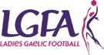
CUMANN PEIL GAEL NA MBAN The Ladies Gaelic Football Association

Páirc an Chrócaigh/Croke Park, Tel: +353 (0) 1 836 3156
Dublin 3 Email: info@ladiesgaelic.ie http://www.ladiesgaelic.ie


COMHAIRLE LIATHRÓID LÁIMHE NA HÉIREANN GAA Handball Ireland

Páirc an Chrócaigh/Croke Park, Tel: +353 (0) 8192385
Dublin 3 Email: nationalmanager.handball@gaa.ie http://wwwgaahandball.ie

COMHAIRLE CLUICHE CORR NA HÉIREANN The Rounders Council of Ireland

c/o Joe O’ Donoghue, Ballinadrum, Tel: + 353 (0) 87 7523003
Ballon, Co. Carlow Email: secretary.rounders@gaa.ie http://www.gaarounders.ie
GAA Anti-Bullying Policy Statement

The GAA aims to create a supportive environment where any form of bullying is unacceptable. We adopt a whole organisational approach to addressing bullying and are committed to implementing structures and relevant training to deal with allegations of bullying. Incidents of bullying are regarded as serious breaches of our Code of Best Practice in Youth Sport - Our Games Our Code. We are committed
to achieving an ethos of respect so as to maximise the potential of all our members when playing or participating in our Gaelic Games.

DEFINITION

Bullying is defined as repeated aggression, be it verbal, psychological or physical, conducted by an
individual or group against others.

THE GAA SEEKS TO ENSURE THAT:

• Incidents of bullying behaviour are addressed appropriately

• All persons in membership of the Association or attending our games or activities are aware that bullying behaviour is unacceptable in the GAA.

DEALING WITH BULLYING

The Code of Behaviour when working with underage players provides good practice guidance in relation to the prevention of bullying.

If you are aware of or have a concern that bullying behaviour is happening within your Club you should
report the matter to your Club Children’s Officer.

We recognise that incidents of bullying are a breach of the Code of Behaviour and of our Give Respect - Get Respect initiative and all such incidents will be dealt with accordingly.

Club Children’s Officer Date

Name of Club

Section 4

unty Children’s Officer

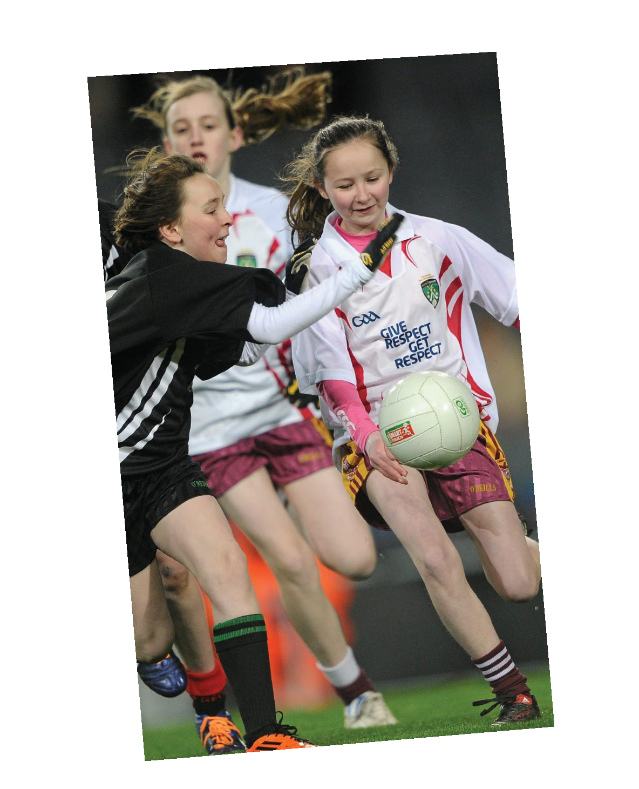
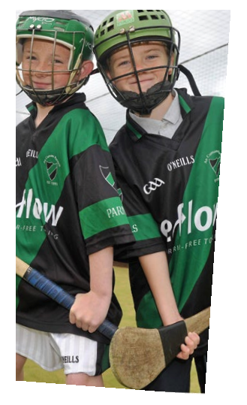
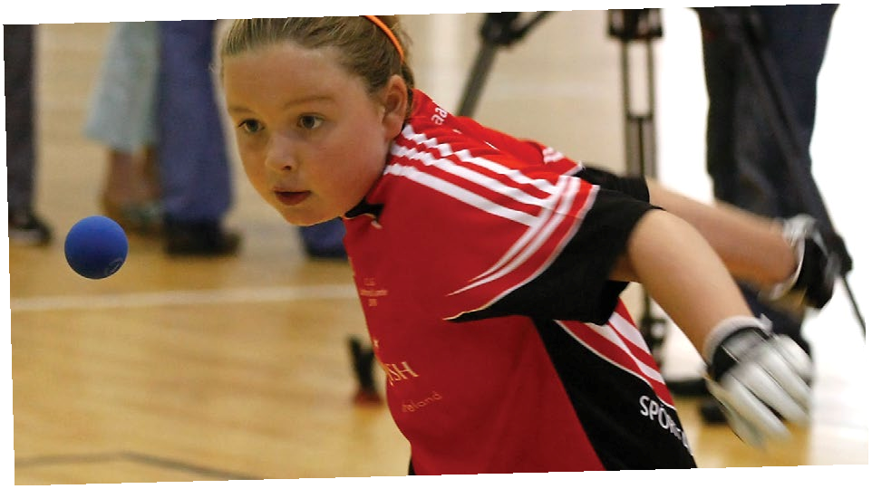
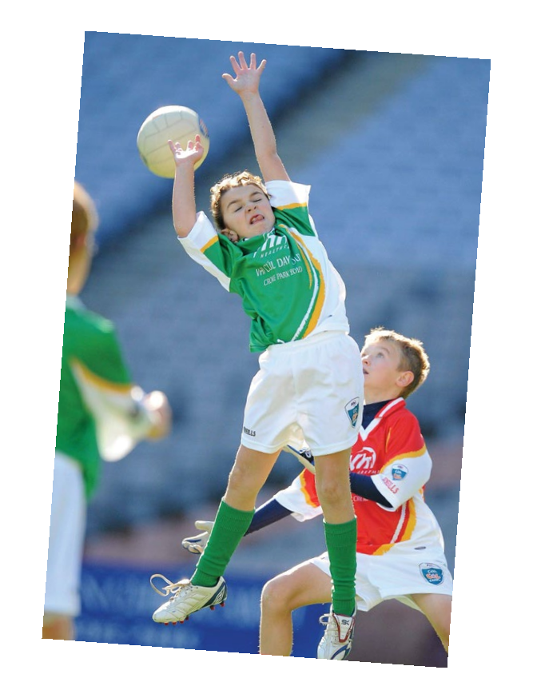
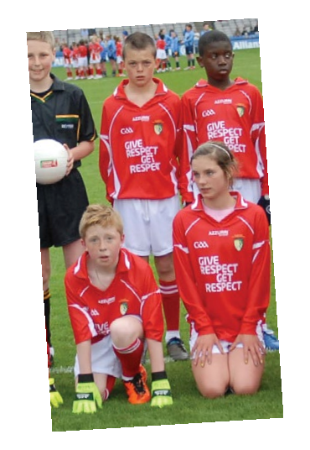
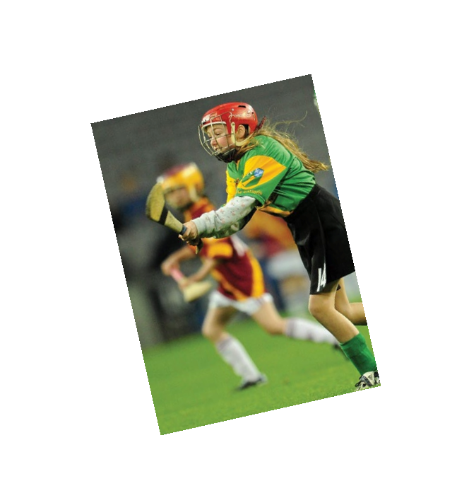

CCCO
The Role of the Club and Co

The Club and County
Children’s Officer

www.gaa.ie

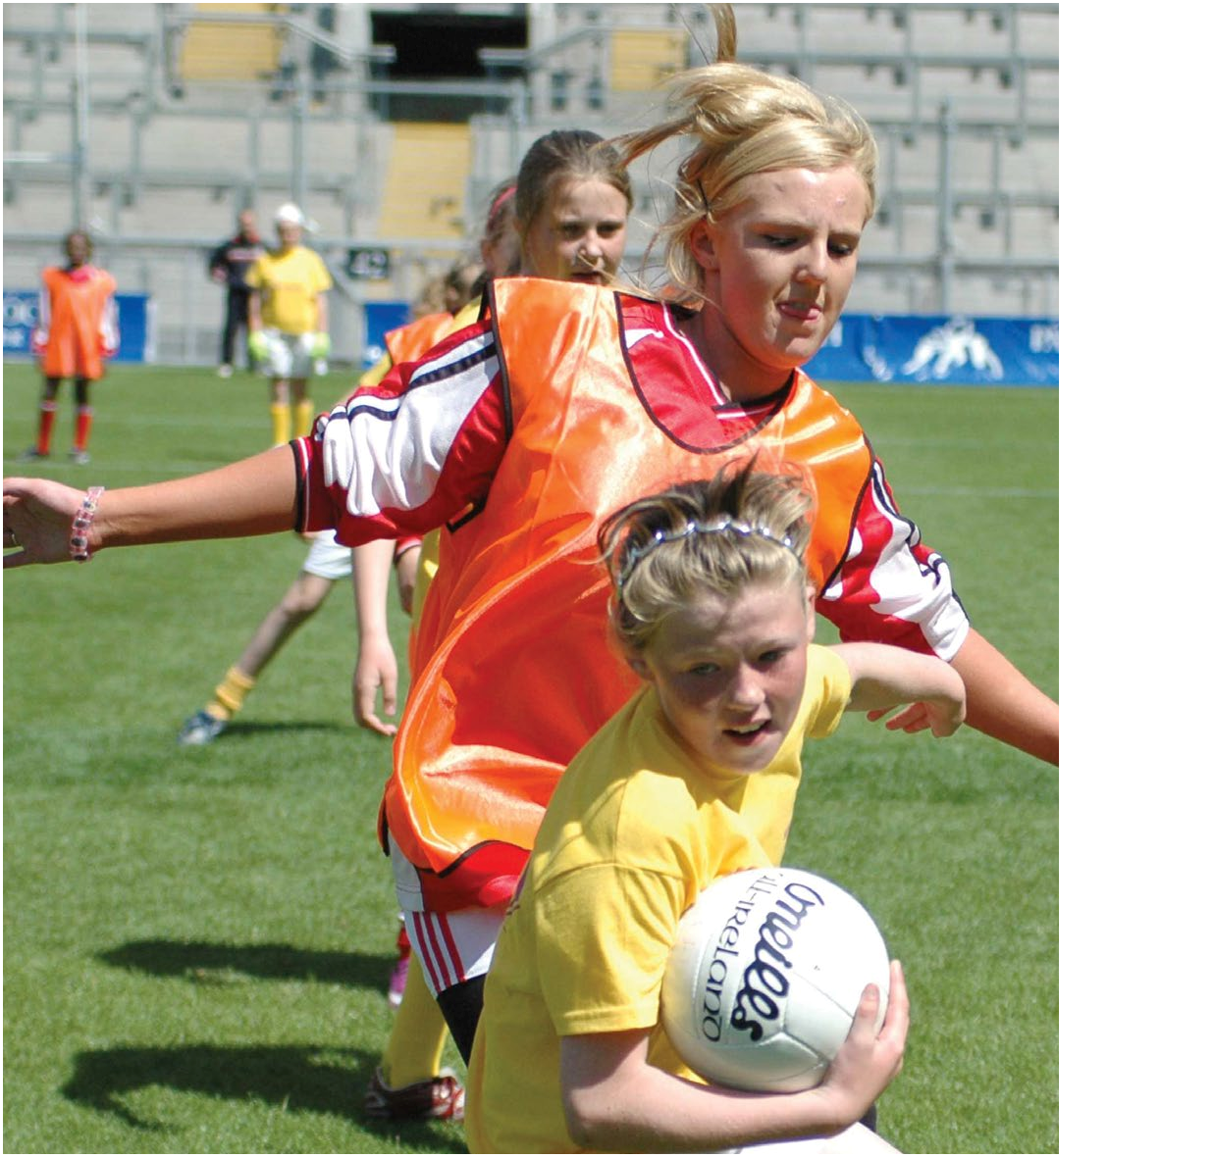
THE CLUB AND COUNTY CHILDREN’S OFFICER

The appointment of a Children’s Officers at both Club and County level is an essential element in the creation of a quality atmosphere and in establishing a child and youth centered ethos at both Club and County level.

All of the Gaelic Games Associations are committed to creating and maintaining the safest possible environment for all young people* who participate in our Gaelic Games and activities. In our work with young people and with adults a number of national policy documents act as a resource and govern our commitments:

• Our Games – Our Code when working with underage players is a joint Code of Best Practice administered by the Gaelic Athletic Association, the Camogie Association, the Ladies Football Association, the Rounders Council of Ireland and GAA Handball Ireland. Our Games – Our Code is a major reference and policy publication covering many aspects of good practice procedures required in running the local Club and also outlines each Associations responsibilities and procedures for dealing with the welfare and safety of underage players when playing our games and participating in our activities

• A Code of Behaviour - when working with underage players - jointly published by the Gaelic Athletic Association, the Camogie Association, the Ladies Football Association, the Rounders Council of Ireland and GAA Handball Ireland. This Code outlines the minimum level of good practice behaviour and practice that we require of our underage players, their parents/guardians, our Clubs, our coaches and supporters

• The Irish Sports Council/Sport NI Code of Ethics & Good Practice for Children’s Sport. This publication establishes a series of principles, policy and practice guidelines for all Sports Organisations that promote their sport with children. Containing a wide range of resources the Code act
as guidance for all Sports Organisations on the island of Ireland

Each of the Gaelic Games Associations complies fully with statutory guidelines and existing legislation in all jurisdictions in which we operate. Additionally all Associations have agreed internal policy procedures, based on their organisational structures, for dealing with any allegations and/or concerns of abuse. Copies of these procedures are available from each of the Associations and from:

Gaelic Athletic Association www.gaa.ie Camogie Association www.camogie.ie Ladies Football Association www.ladiesgaelic.ie Rounders Council of Ireland www.gaarounders.ie GAA Handball Ireland www.handball.ie

The appointment of a Children’s Officer at both Club and County level while deemed essential
is also a mandatory requirement. These Officers fulfil a key role at Club and County level and are members of the relevant Club Executive and County Committees. This leaflet outlines the roles and responsibilities of Children’s Officers as a guide for those who undertake such key roles on our behalf.

*Young People – The term ‘young people’ denotes any person under the age of 18 years.
The Club Children’s Officer

The Club Children’s Officers shall assist in promoting a child and youth centered ethos in the Club. In their work the Club Children’s Officer shall be the link between the children/young people and the adults within the Club. In taking up this role the Club Children’s Officer should:

• Have good communication skills, be approachable and open minded
• Have good knowledge and be familiar with their Child Welfare and Protection Codes and Guidelines
• Have an understanding of relevant child welfare/protection legislation
• Have undertaken a Garda Vetting/Access NI/CRB check relevant to their jurisdiction
• Have attended the relevant awareness training on child welfare and protection and availed of
Children’s Officer training

ROLE
The key role of the Club Children’s Officer is to ensure the implementation and promotion of
the relevant Child Welfare and Protection Codes and Guidelines for good practice in their Club so
as to ensure that young people can participate, enjoy and benefit from our Gaelic Games in safe
and enjoyable surroundings. Our Games - Our Code is the agreed good practice reference and policy
document that is central to guiding the Children’s Officer in their role.

RESPONSIBILITIES

• Promote awareness of Our Games – Our Code and the joint Code of Behaviour within the Club
• Identify the need and facilitate the delivery of Child Protection in Sport Awareness Workshops and other relevant Child Protection and Welfare training within the Club
• Distribute and oversee the implementation of the Joint Code of Behaviour – when working with underage players and ensure in so far
as possible, that all Players, Coaches, Team Mentors, Parents, Guardians, Officials and Spectators adhere to the Code
• Promote an Anti Bullying ethos in the Club and deal with instances or allegations of Bullying in a fair, impartial and constructive manner and
in collaboration with others as appropriate

• Ensure that each under age member signs and submits an annual membership form, a parental consent form as required (away
trips etc) and that the necessary medical information of an underage player, as deemed relevant, is made known to the Club and/or the team coaches
• Support the implementation of the RESPECT initiative at Club level in co-operation with team personnel, underage members, referees, spectators, parents and guardians
• Influence policy and practice in the Club in order
to prioritise the needs of our underage players

• Promote greater consultation with under age players and participation by them in Club activities and planning
• Ensure that young people are afforded the opportunity to express concerns about their sports activities/experiences within the Club
• Encourage the involvement of parents/
guardians in organising Club activities

• Develop good practice procedures in the recruitment and selection of persons working with young people in the Club
• Oversee the implementation of Garda Vetting/ Access NI/CRB checks, as appropriate, within the club
• Monitor, in association with team coaches, any
significant trends or developments relating
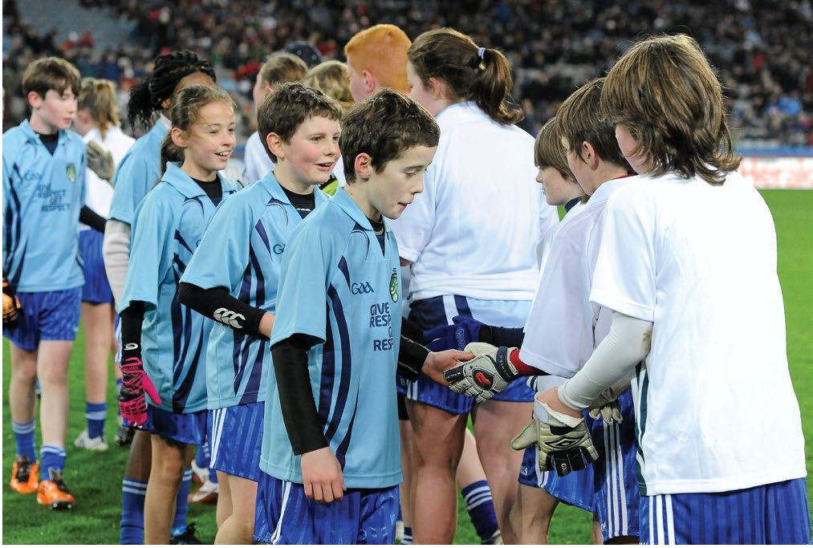
to the participation of young people in Gaelic Games and report accordingly to the Club Executive or Management Committee
• Maintain on-going contact with the County Board Children’s Officer and with other Club Children’s Officers
• Report regularly to the Club Executive
Committee as required
• Ensure that the Club Executive Committee appoints a Code of Behaviour Advisory Committee each year to assist the Children’s Officer in fulfilling their roles. (see Code of Behaviour)
• Deal with breaches of Our Games – Our
Code and the joint Code of Behaviour as per relevant guidance
• Make referrals of alleged allegations of abuse to the Club Designated Person
• Conduct an annual audit of best practice in child protection and welfare within the Club and report accordingly

The County Children’s Officer

In the context of promoting and implementing our commitment to creating a safe and enjoyable environment for all young people* who participate in Gaelic Games and activities, County Boards are obliged at the outset to appoint a County Children’s Officer. The County Children’s Officer’s shall be a member of the County Committee and should:

• Have good communication skills, be approachable and open minded
• Be familiar with their Child Welfare and Protection Codes and Guidelines
• Have undertaken a Garda Vetting/Access NI/CRB check relevant to their jurisdiction
• Have attended the relevant basic awareness training on child welfare and protection and Children’s
Officer training
• Be familiar with relevant child welfare/protection legislation
• Have a commitment to attend other relevant training as required
• Have the confidence of all Clubs and in the particular of Club Children’s Officers within the County

ROLE
The key role of the County Children’s Officer is to oversee the implementation and promote an awareness of Our Games – Our Code and the joint Code of Behaviour with the co-operation of Clubs in the County and with Club Children’s Officers.

The County Children’s Officer

RESPONSIBILITIES

• Ensure that each Club has appointed a Club Children’s Officer and that these Children’s Officers are aware of their roles and responsibilities

• Regularly liaise with all Club Children’s Officers; respond to their queries; support and assist them to develop and implement an annual
work plan

• Promote and co-ordinate Child Protection in Sport Awareness Workshops for all Clubs in the County

• Liaise with Child Protection in Sport Awareness Workshop Tutors and ensure that all Club and County personnel receive child welfare training relevant to their roles

• Ensure that all tutors adhere to Association and legislative requirements in the delivery of their workshops

• Ensure that the activities of underage County Development Squads and County underage teams’ activities are compliant with the relevant Gaelic Games Codes, with the RESPECT initiative and with relevant playing models, in co-operation with Coiste na nÓg as appropriate

• As required, liaise and advise the County Coaching and Games Development structures on strengthening a child centred ethos in their programmes and activities

• Assist, if required, the County Vetting
Co-ordinator in the processing of vetting applications on behalf of the Association to the relevant authorities
• Advise on good practice in the recruitment and selection of persons working with young people at Club and County level

• Promote greater consultation with under age players and participation by them in Club and County activities

• Deal with breaches of Our Games – Our Code and the joint Code of Behaviour as per relevant guidelines

• Monitor and report on any significant trends or developments relating to the participation of young people in Gaelic Games

• Review and report to the County Committee on the extent and nature of implementation of the relevant Association Codes within the County and by Clubs

• Maintain regular communication and liaison with the National Children’s Officer and provide reports as required

• Provide an Annual Report to each Annual
County Board Convention

Code of Best Practice in Youth Sport






Code of Best Practice in Youth Sport

GAA, Páirc An Chrócaigh, Baile Átha Cliath 3

Guthán +353 1 836 3222
Faics +353 1 836 6420 nationalchildrensoffice@gaa.ie www.gaa.ie
GAA, Croke Park, Dublin 3

Tel +353 1 836 3222
Fax +353 1 836 6420 nationalchildrensoffice@gaa.ie www.gaa.ie



This leaflet, is published and promoted by the Gaelic Athletic Association, Camogie
Association, Ladies Football Association, Rounders Council of Ireland and
GAA Handball Ireland

Tá leagan Gaeilge den bhileog seo ar fáil ar www.gaa.ie/clubzone

Section 5
Club Activities For Underage Players
Away Trips, Hosting an Event and Transport

Away Trips

Many teams and Clubs participate in trips away from home throughout the year. These trips are seen as additional to the regular games that take place as part of a County fixtures schedule or during inter Club blitzes. Trips away from home are often viewed as a means by which young teams and players may be rewarded for their endeavours at the end of their season or as a means by which greater team morale and camaraderie can be developed, regardless of age.

An example of rewarding a team or organising a trip is to invite the team or a number of teams to attend inter-county matches. This is a popular means by which young people may see and attend games where their chosen code is played at a high level of skill and competitiveness. Visiting other clubs and playing matches against teams of a similar age group in other areas or counties will also give younger players an insight into the broad geographical nature and community ethos attached to our Games while creating greater camaraderie with their colleagues and within their own clubs.

The pre-planning and detailed organising of such trips for younger players will require a high degree of care and preparation and adults should always remember the key roles of responsibilities they have during such trips on behalf of their club, on behalf of parents and on behalf of the young people themselves.

PRE TRIP PREPARATIONS

• A detailed programme of activity should be approved in advance at Club level following agreement with the other club(s) involved in the away trip.
• Where possible a member of your organising group should be familiar with the away venue, should visit the venue if deemed necessary and ensure themselves that the venue can cater for the entire programme of activities. This is particularly relevant should an overnight stay be required.
• Parental/guardian consent must be obtained in writing so as to permit any young person under 18 yrs of age participate in any organised trip.
• Young people (of an appropriate age) and their parents/guardians should sign a form agreeing to abide by the programme and to any agreed procedures that relate to the organised trip.
• An agreed Code of Behaviour, specifically designed for the trip, should be discussed, outlined and
agreed with all players and adults that are participating on the trip.

• Medical information, deemed relevant by the parents/guardians of players, should be made known
to the leaders of the Club’s trip and what action, if any, may be may be required of them in the case of an emergency. (See Appendix 1)
• Such information, including food or other related allergies should have previously been recorded on the annual/registration form of each underage club member.
• A detailed programme which includes the following should be presented to all players and their parents/guardians:
• A time schedule of departure and arrival at your destination.
• Full information about the trip; including all activities and events planned.
• Emergency contact numbers during the trip and contact details for parents/guardians

• All adults accompanying the underage team should be made aware as to what their responsibilities are and what role(s) they may have during the trip.
• It is the Club’s responsibility to ensure that the trip itself and all activities taking place throughout the trip adhere to insurance cover, that all participants are eligible members of their Association’s relevant injury scheme and that the activities of the trip do not compromise the conditions of their injury scheme or any additional insurance policy.
• Where it is deemed necessary the organisers of all such trips should seek and gain the permission of their County Board prior to announcing the details of the programme to their members.

DURING THE TRIP

• It is essential that at least one individual with first aid qualifications be part of your organising
group and that this individual be present or available throughout the trip.

• Young people must be adequately supervised throughout the trip as per our recommended ratios of adults to young people. This ratio may differ depending on the age group of participants, the activities to be undertaken, whether there is an overnight stay, if the trip is abroad etc.
• A generally acceptable ratio of 1:8, i.e. one adult per eight young people, is deemed in most instances to be a normal sports activity ratio. Organisers of club trips should always be mindful of ensuring that additional adults accompany their group in case of emergencies or unforeseen circumstances.
• There must be at least two adults of each gender with mixed groups.

• Adults are required to be familiar with the agreed rules on smoking and on the consumption of alcohol during the trip, as outlined in the GAA Code of Behaviour. As a basic minimum, adults are required to avoid smoking while working with young players and must not consume alcohol or non prescribed drugs while young players are in their care.

OVERNIGHT STAYS

When participating in an overnight stay a number of matters require careful preplanning and agreement.

By agreement with all parties, including players and parents, a decision is required whether the Club will avail of hotel or guest house accommodation or if invited will avail of a hosting arrangement by the host Club in the houses of their Club members.
Regardless of what form of accommodation is agreed upon adequate and specific supervisory ratios of adults to children must be agreed in advance. This ratio, which is very dependent on the age category of the children/young people, may also vary should the group be participating in certain outdoor activities or in water sports and will also vary if the group is a mixed gender group.

HOTEL OR GUEST HOUSE ACCOMMODATION
• Check out the proposed accommodation for children/young people and Club mentors. Ensure that it complies with health and safety regulations, is accessible, is of a suitable standard and is appropriate for the particular age group and programme of events.
• When availing of overnight accommodation adults (except parents) should not share a room with a child. If exceptional or emergency circumstances so dictate and the presence of an adult is deemed necessary there should be more than one child in the room with the adult at all times.
• Where children are sharing a room it must be with others of the same age grouping and gender.

• All children should be provided with a bed each and should not have to share a bed with another child.
• It is also preferably that the sharing of rooms be done with fellow club members at an inter club event and that such arrangements are made known in advance of the trip to the childrens’ parents.

HOME STAY ACCOMMODATION

• When availing of home stay accommodation the host club is responsible for choosing a host family that has been recommended to them and have been satisfactorily vetted in accordance with Association requirements.
• When availing of home stay accommodation adults (except parents) should not share a room
with a child. If exceptional or emergency circumstances so dictate and the presence of an adult is deemed necessary there should be more than one child in the room with the adult at all times.
• When availing of home stay accommodation Children must not share a room with adults from the host family.
• All children should be provided with a bed each and should not have to share a bed with another child.
• Where children are sharing a room it must be with others of the same age grouping and gender. It is also preferably that the sharing of rooms be done with fellow club members at an inter club event and that such arrangements are made known in advance of the trip to the childrens’ parents.

REVIEW OF TRIP

A full review of the trip should involve all who participated from the club and the result of the review should be retained and reviewed if and when the group intend organising another or similar trip or if the club intends re-visiting the area or the host club again.
Hosting An Event

The hosting of a schedules game, a challenge match, an underage blitz or an inter Club tournament is now seen as a normal event for most Clubs in Hurling, Football, Camogie, Ladies Football, Rounders and Handball.

While most events are organised by age category and by chosen code so as to provide inter club games and offer skill development opportunities these event by their very nature can also provide young people of all ages with a positive social experience allowing them enjoy themselves within a safe environment.

The safeguarding criteria and guidance that applies to away trips, recruitment, travel, health and safety to the hosting of an event with the additional responsibility that when hosting you are organising the games or the event for more than your own Club or team.

A NUMBER OF GROUND RULES APPLY TO HOSTING AN EVENT.

1 Don’t be pressurised into offering to host an event if you cannot do it or if you do not have
adequate resource of facilities to cater for the proposed event.

2 Be absolutely clear that you have the full support of your own Club when embarking on hosting an event

3 Clarify with those that requested of you host the event (e.g. Juvenile Board, Féile Committee ...)
what is required of your Club

4 Form an organising team, with a nominated person in charge, to oversee the hosting

5 Allocate specific responsibilities to each member of the organising team

6 Agree a timescale and a plan for the delivery of all of your actions (see draft action plan)

7 Agree your plan or outline your plan with the governing body who requested your Club to host the event (e.g. Juvenile Board, Féile Committee ...)

8 Meet regularly to review all work in progress

9 If you are providing a home stay option for your guest Clubs you must abide by the guidance given under the Home Stay Accommodation

10 Never presume that somebody else had done it!
EVENT ACTION PLAN

Event:
INTER CLUB UNDER 14 TOURNAMENT

It is very useful to draw up an event action plan that can be used as a guide for all persons working on the event and also as a check list for the organising committee in reviewing their progress to date.

Below is the commencement of an Event Action Plan for an U14 Inter Club Tournament that your Club
had been invited to organise by the County Board. It contains some identified actions and sufficient blank spaces for the identification and delivery of other actions. You have eight weeks notice of the event. Complete this event plan in advance of meetings and as your preparations develop and are completed.

ACTIONS | By When? (Date) | Responsibility? (Name) | Done? (Date)
APPROX 8 WEEKS BEFORE EVENT
Accept invitation to host event | 8 weeks before | Relevant Club Committee
Establish Organising Committee and named person in charge | 8 weeks before | Appointed by Club Committee
1st meeting of Tournament  Committee | 7 weeks before | Organising Committee Chair
Allocate responsibilities at  1st meeting |  | Name the tasks and people
Agree correspondence to visiting  Clubs |  | Agree with Secretary
Prepare budget at 1st meeting |  | Responsibility of Treasurer
Identify sponsors (if appropriate) |  | Overseen by Treasurer
Book pitches or venues as appropriate |  | A Committee member
Agree on home stay option and plan accordingly (see Home Stay Accomodation Section)
APPROX 6 WEEKS BEFORE EVENT
Organising Committee meeting
Post correspondence to visiting
Clubs with relevant forms etc
Check insurance implications if any
Complete event plan and circulate
Check out all venues by visit

Our Games Our Code Code of Best Practice in Youth Sport
page 36

APPROX 4 WEEKS BEFORE THE EVENT
Organising Committee meeting
Confirm participating teams and
Clubs
Make ‘draws’ and circulate information
Arrange for First Aid at tournament
APPROX 2 WEEKS BEFORE THE EVENT
Organising Committee meeting
A team withdraws from the
Tournament
Organising Committee meeting

Our Games Our Code Code of Best Practice in Youth Sport
page 37

APPROX 1 WEEK BEFORE THE EVENT
2nd team withdraws from tournament
New sponsor seeks role in the
Tournament
DAY OF THE TOURNAMENT
Register each team and their coaches
Check dates of birth
AFTER THE EVENT REVIEW
Organising Committee meeting
Financial report

Our Games Our Code Code of Best Practice in Youth Sport
page 38

Transport

Adequate preparation and an insistence on the use of safe transport arrangements regardless of the length of journey are key elements of good practice when considering any trip taken by an underage team or players. This applies regardless of the length of journey or indeed the mode of transport availed of, whether it is public, private or personal transport.

The transport arrangements for underage players is a priority safety matter for sports organisations, for Clubs, parents and for young people themselves. While it may be preferential to avail of private bus or coach transport it is also recognised that in some instances this is not feasible and certain Clubs and teams could not operate without the goodwill of volunteers and parents who ensure that children are transported to an event or a match and are returned safely.

In so far as we rely on many parents to provide transport in our clubs the challenge we face in ensuring that all such services are provided in a safe environment that compiles with our own standards of good practice and with local or national legislative requirements.

It is recognised that private cars are used by many Clubs and teams as a common practice when transporting children to games as part of a County fixtures schedules or as part of inter club blitzes. It is however advisable if possible not to use members’ cars when travelling on away trips of great distance. In such circumstances Clubs are advised to avail of bus or coach transport and it is essential therefore that all aspects of the transport arrangements are checked out and agreed in advance. The safety and welfare of children is paramount and must be considered a priority at all times when transporting our underage players from one venue to another.

A NUMBER OF BASIC REQUIREMENTS APPLY WHEN TRAVELLING TO GAMES AS FOLLOWS:

• That every parent has supplied at least two emergency contact numbers to the team Coaches that may be used in the event of an emergency concerning their child or the group or in the event of a change in schedule
• That all players may travel following parental/guardian consent

• That any medical conditions of players are made known to Coaches in advance of any trip and as part of the annual registration process
• That parents are supplied with the contact telephone number of the Coach in charge on the day and of any other accompanying Coaches
• That any particular rules or regulations relating to a trip are made known to parents and children alike and agreed in advance of departure
• That the Club is satisfied that the proposed trip has been planned and agreed in accordance with
child welfare procedures where the safety of the child is paramount in all preplanning of the trip
BUS AND COACH TRANSPORT:

The following should be considered when availing of bus and coach transport:
• The company chosen must be a reputable transport company with a proven track record in transporting children
• All vehicles should be well-maintained and roadworthy and should be properly taxed and insured

• Transport should be fully accessible for people with disabilities whether they are members of the group or for others who may accompany them.
• Seat belts must be worn at all times on buses and coaches.

• Alternative transport should be available in case of emergency.

• Vehicles should be equipped with a First Aid kit and a fire extinguisher and leaders of the group
should be familiar with how to use them.

• When hiring a vehicle Club personnel should have no hesitation in enquiring as to the company’s reputation and reliability.
• Adult coaches should ensure that children remain safely seated at all times during the journey.

• An adequate ratio of adults to children on the bus must be ensured at all times taking the age of the group members into consideration and the need for male/female ratios with mixed gender groups

PRIVATE TRANSPORT IN CARS

If an adult has to transport a child/children there are a number of safety measures that should be agreed so as to minimise any potential child welfare or safety risks to their children and or adults:
• If a child is being transported by car the parents of the child should be informed as to who will be transporting their child, why this mode of transport has been chosen, how long the journey may take, the departure time and the estimated time of return
• It is important that children are comfortable with whoever may be the driver of the car in which they travel and are made aware as to what are the transport arrangements made for them by their Club
• Drivers must ensure that they have adequate insurance to carry the required number of passengers

• If the driver is in a paid position in the Club or in the Association or is in receipt of expenses for the trip they may be required to have additional insurance cover to enable them transport any passengers
• Central collection and drop off points are recommended when transporting children

• The driver (and other team personnel) should be contactable by mobile phone in case of emergencies
• With the exception of their own child an adult should not transport a child alone, except in emergency or exceptional circumstances
• In accordance with transport legislation where applicable children must use appropriate child restraints and seat belts when travelling in a car or other vehicles
• No driver should ever consume alcohol or non prescribed drugs prior to driving

• No driver should smoke in the car when transporting children on behalf of the Club or Association

• Where a driver may be under medical care or taking prescribed medication he/she must ensure that such medication may not inhibit their driving abilities
• All drivers and persons who have access to children on our behalf should have undertaken a vetting background check in accordance with the Association’s guidelines and should have been informed that their vetting application has been accepted

PUBLIC TRANSPORT

When using public transport please ensure that
• That the full travel schedule is made known in advance to all parents and players

• That drop off and pick arrangements have been agreed in advance

• That where available, seat booking arrangements are agreed in advance e.g. trains

• That an adequate number of adults accompany the group in a supervisory role

• That a contingency plan is in place in case a scheduled public transport arrangement or booking is cancelled, is late, or has been missed by the group
Section 6
Recruitment and Selection of Coaches, Mentors and other Volunteers

From their early years to their late teens young people continue to gain from the knowledge, experience and skills that adults bring in the promotion of our Gaelic Games. Such an approach promotes a sense of achievement, an opportunity to develop their skills and a sense of fun and fair play in our underage games as these players seek to enjoy, benefit and develop from their involvement.

Our Games have always been promoted amongst our younger population in a well motivated and committed manner so as to assist our younger players in the development of their skills and their commitment to our Gaelic Games. This support, led primarily by adults who work in a voluntary capacity, must always be delivered in accordance with Association guidance and standards. We greatly rely on the thousands of adults, whether it is parents or coaches, who give freely of their time to our juvenile structures and underage membership, but equally recognise that their contribution is, at all times, in accordance with our own guidance and statutory requirements.

This is still the case and those who promote our games have a responsibility to young people and to their parents and guardians to ensure that our coaches and mentors, who work in a supervisory and supportive capacity with our underage teams, are selected supported and trained to fulfil their roles in a careful, sensible and effective manner.

This unique bond in sport is based on a trusting and mutually respectful relationship and can be enhanced by the recruitment, selection and up-skilling of adults who are suitable to such roles. While the role of the adult may vary from team to team and from age group to age group it is however essential that regardless of such roles that adults are fully aware at the outset as to what is expected of them, what supports they will receive and what levels of responsibility they themselves have on behalf of the team, the club, the parents and the young people in their care.

This we can achieve by adopting good practice procedures when recruiting our managers, coaches and other personnel who work with children and young people.

Statutory guidance and legislative requirements are now more stringent when recruiting adults to work with children. These requirements apply to our Gaelic Games as they do all sports bodies or to youth clubs or other recreational or educational services. We are duty bound to ensure that all adults who work with children and young people in our Associations are carefully chosen to carry out whatever tasks we ask
of them and that they are vetted or undergo criminal background checks prior to them, taking up any supervisory or coaching role. Similarly , we must ensure that all such adults are suitably trained to fulfil their roles and that we have adequate numbers of adults in place for all occasions so as to satisfy the necessary child welfare ratios of adults to children currently in place.

The following recruitment and selection guidelines are put in place as a support mechanism so as to ensure that those recruited adhere to the best possible standards that we have adopted in ensuring that our Games are played and promoted in a an enjoyable, safe and developmental environment.
Guidance on Recruitment and Selection

It is essential that all adults taking responsibility for young people, whether in a paid or unpaid capacity should undergo a recruitment and selection process. The recruitment of adults to work with underage teams should be co-ordinated by a senior and experienced member of the club and should be done so in a confidential manner. The following procedures will assist Clubs when choosing to place coaches and other personnel in the position to which that are best suited.

1 Role clarification
The role envisaged e.g. manager, coach, and the age group that it is proposed they should work with should be clearly known and stated at the outset. The responsibilities relating to the role and the level of experience or qualifications required should be clarified at the outset.
2 Role assistance
The various supports available via the club, e.g. Foundation Level Coaching, child Welfare Training are basic good practice coaching requirements for adults who wish to work with underage teams in the promotion of our Gaelic Games.
3 Application form
Applicants should complete an application form prior to commencing any role when working with underage players. (See Appendix 2).
4 References
As part of the recruitment process references should be sought from applicants. These may refer to the person’s character and if applicable to the applicants previous background in sports and in Gaelic Games, if applicable. All references should be verified by the club.
5 Vetting and Police checks
All applicants are required to complete Garda Vetting and/or Police Checks, as appropriate, prior to the commencement of their role(s) with young people in the Association.
6 Meet the applicant
A senior representative of the Club should meet with each applicant to ensure that they are aware of the role(s) allocated to them and they may use the occasion to clarify any issues that may arise and identify any coaching or up-skilling needs as appropriate.
7 Code of Behaviour for all Persons Working with Underage players
All persons who work with young people will be required to sign the Code of Behaviour. This declaration should be retained by the Club in respect of everybody working with underage personnel, regardless of their role.
8 Child Welfare Training
All persons working with underage players are required to undertake recognised Child Welfare
Training as promoted by their Sport’s Governing Body.
9 Support and Review
Continuous supports should be made available to all coaches etc so as to enable them fulfil their roles as requested. The role of the Club ‘Coiste na nÓg’ and of the Club Children’s Officer may be invaluable in identifying such supports. The Club should review the role of all underage personnel on an annual basis.
Delivering a Vetting Service at Local and National Level

DELIVERING A VETTING SERVICE AT LOCAL AND NATIONAL LEVEL

The vetting of Coaches, Mentors and other personnel who work with children and young people is as a core element of good recruitment and selection procedures in all sports organisations.

The GAA, Ladies Gaelic Football Association, the Camogie Association, GAA Handball Ireland and The Rounders Council of Ireland support the mandatory requirement that all persons who work on our behalf with children and young people must be vetted or have a criminal background check carried out in the jurisdiction in which they operate, before they work with children.

Regardless of legislative requirements this is now a key element of our welfare and protection strategy and of our recruitment practices. In effect this means that any person working on our behalf or on behalf of any of our Clubs with people under the age of 18 years of age or with vulnerable adults is now required to be vetted.

Applicants will be vetted and re-vetted as necessary in accordance with the roles that they fulfil and any
directives relating to such vetting procedures in whatever jurisdiction in which we operate.
DELIVERING A GARDA VETTING SERVICE AT NATIONAL AND LOCAL LEVEL IN CUMANN LÚTHCHLEAS GAEL (GAA), THE ROUNDERS COUNCIL OF IRELAND AND GAA HANDBALL IRELAND

GARDA VETTING BACKGROUND CHECKS

Garda Vetting is but one part of the overall recommended recruitment and selection procedures for those who on our behalf work in areas of responsibility with children and young people, or who may do at a later stage. Garda vetting, which is the pre-checking of an applicant’s background for criminal convictions or prosecutions is recommended by the Irish Sports Council, by Sports NI in Northern Ireland and as part of Children First - the National Guidance for the Protection and Welfare of Children.

While most vetting applicants are adults i.e. over 18 yrs of age, it is permissible to have persons aged between 16 and 18 yrs of age vetted by the GAA, but only with written parental consent.

The GAA carries out a vetting service on behalf of GAA Hurling and Football Clubs, on behalf of GAA Handball Ireland, the Rounders Council of Ireland and Scór.

HOW CAN YOU AVAIL OF VETTING IN THE GAA?

STEP1 | A vetting applicant, i.e. an underage coach, mentor, manager etc. will generally receive a GAA Vetting Application Form from the Club’s Children’s Officer. This form must be completed in full by the applicant and collected locally (in the club) or forwarded directly to a nominated person who will collate these forms at and forward them to the GAA National Children’s Office in Croke Park.
STEP2 | Prior to forwarding these forms to Croke Park they will be checked by a suitable person, nominated by the County Board. This person will check forms for accuracy and will return incorrectly completed forms to applicants. The County Board nominated person will also record the name and address of each applicant on a ‘batch form’ and send this electronically to the National Children’s Officer in Croke Park.  Training is provided for this person so as to assist them in their role.
STEP3 | All forms are then sent by secure post to the National Children’s Officer, GAA, Croke Park, Dublin 3. All forms must be sent to the National Children’s Officer (NCO) in Croke Park for processing and not to An Garda Síochána.  The NCO will then process all correctly completed forms with the Garda Central Vetting Unit. Processed forms will on their return contain a statement that there are either no convictions recorded against the individual in the Republic of Ireland or elsewhere, or  a statement relating to convictions and/or prosecutions, successful or not, pending or completed, as recorded against the applicant in the State or elsewhere as the case may be.

STEP4 | Following the processing of the vetting form it is the GAA National Children’s Office who will inform  each applicant individually by letter if their vetting application has or has not been accepted. In most instances it is convictions and/or prosecutions of a most serious nature and particularly against children/minors that MAY deem a person unsuitable to work with children in the GAA.  Please also note that a stated conviction or unsuccessful prosecution MAY have NO bearing whatsoever on the acceptance of an individual in the Association and it is recommend that all cases be treated individually and confidentially and that they be assessed as per the requirements of the post/role and the work that it entails.
STEP5 | If the recommendation is positive the applicant will receive a GAA Garda Vetting Acceptance letter confirming that their application has been successful and directing them to furnish their club with the letter of acceptance.  Over a period of time all persons who on behalf of the GAA work in any capacity with children and young people will have furnished their Club with a GAA Garda Vetting letter of acceptance. The absence of such a letter will deem a person ineligible to work in such a capacity.
STEP6 | If the recommendation is negative and if the applicant is not being recommended for acceptance a letter informing them of this decision will be sent to them by the GAA National Children’s Officer. The applicant will be afforded an opportunity to appeal this decision  within 14 days and the process of appeal will be outlined to the applicant. A specially appointed Appeals Group will hear this appeal and will issue their findings directly to the applicant.
STEP7 | If the Appeals Committee recommends acceptance of the vetting application Step 5 comes into operation.
STEP8 | If the Appeals Committee upholds the recommendation of rejection the applicant and their Club Chairperson will be duly informed. This will prohibit that applicant from working in any capacity with children in their Club or in any other section or unit of the Association.
STEP9 | The GAA central data base will retain all vetting application and outcome details. Club Children’s Officers will be issued with a list of persons who receive the Garda Vetting ‘letter of acceptance’ from the National Children’s Officer on a regular basis.
STEP  10 | Individual applicants may, at the discretion of the GAA National Children’s Office, be re- vetted at any time or will be re-vetted in accordance with legislative guidance on re-vetting in whichever jurisdiction in which we operate.

Our Games Our Code Code of Best Practice in Youth Sport
page 46

PROTOCOL ON VETTING APPLICATION OUTCOMES

There are established procedures in place to conduct vetting of all persons who work in any capacity with children, young people and vulnerable adults in the delivery of our games and activities.

The GAA, GAA Handball Ireland and the Rounds Council of Ireland recognises that there is a standardised vetting system operated by the Camogie Association and by Ladies Gaelic Football, which functions for the purpose of determining the suitability of personnel to deliver our games and activities in settings which may facilitate unsupervised access to children and/or vulnerable adults, within each of the above bodies.

The status and validity of decisions reached in each body in respect of the suitability of an individual for a position within it is acknowledged and accepted by each other body.

GARDA VETTING SERVICES BY THE CAMOGIE ASSOCIATION

The Camogie Association has implemented Garda Vetting in the Association as we promote best practice in the recruitment and selection of persons to work with children and young people in our Association.

It is but one part of the overall recommended recruitment and selection procedures for those who work on our behalf in areas of responsibility with children, young people and vulnerable adults, or who may at a later stage seek to work in such areas of responsibility.

Garda vetting, which is the pre-checking of an applicant’s background for criminal convictions or prosecutions is recommended by the Irish Sports Council, by Sports NI in Northern Ireland and as part of Children First: National Guidance for the Protection and Welfare of Children. Vetting and Police checks have been utilized by many Governmental agencies and by sports and community based organizations for a number of years.

PROCEDURE FOR SUBMISSION OF COMPLETED FORMS CLUB
Club Children’s Officer to initiate process within club by the distribution of Garda Vetting Application
forms to club officers and officials. Application Forms to be returned to the Children’s Officer in a sealed
envelope marked – Garda Vetting Application forms.
Club Children’s Officer will then pass on a bundle of unopened envelopes in a sealed envelope to the
Garda Vetting Officer within An Cumann Camógaíochta.

The Garda Vetting Officer within An Cumann Camógaíochta examines the application forms and if completed correctly forwards them to the Garda Central Vetting Unit. If a form is not completed correctly it is returned direct to the applicant for correction.

COUNTY
County Children’s Officer to initiate process within the county by the distribution of Garda Vetting Application forms to officials of development squads and underage county teams. Application Forms to be returned to the County Children’s Officer in a sealed envelope marked – Garda Vetting Application forms.
County Children’s Officer should then pass on a bundle of unopened envelopes in a sealed envelope to the
Garda Vetting Officer within An Cumann Camógaíochta.

The Garda Vetting Officer within An Cumann Camógaíochta examines the application forms and if correct sends them to Garda Vetting Unit. If the application form is not completed correctly it is returned to the member for correction.

FORMS
Garda Vetting Forms can be downloaded below. They must be printed double sided as a single page. A
Parent / Guardian consent form must be filled for applicants between the ages of 16 and 18.

ACCEPTANCE LETTERS
Following the processing of the vetting forms successful applicants will be notified by letter from An Cumann Camógaíochta. This letter is a valuable document and must be retained. An official, date stamped copy of the letter will also be included; this copy must be given to the Children’s Officer who will keep it on file.
Club Children’s Officers or Secretaries can request an updated list of its members who have been vetted by contacting An Cumann Camógaíochta Vetting Officer.

PROTOCOL ON VETTING APPLICATION OUTCOMES

There are established procedures in place to conduct vetting of all persons who work in any capacity with children, young people and vulnerable adults in the delivery of our games and activities.

An Cumann Camógaíochta recognises that there is a standardised vetting system operated by Cumann Lúthchleas Gael, Ladies’ Gaelic Football, Irish Handball Council and The Rounders Council of Ireland, which functions for the purpose of determining the suitability of personnel to deliver our games and activities in settings which may facilitate unsupervised access to children and/or vulnerable adults, within each of the above bodies.

The status and validity of decisions reached in each body in respect of the suitability of an individual for a position within it is acknowledged and accepted by each other body.
GARDA VETTING SERVICES BY LADIES GAELIC FOOTBALL

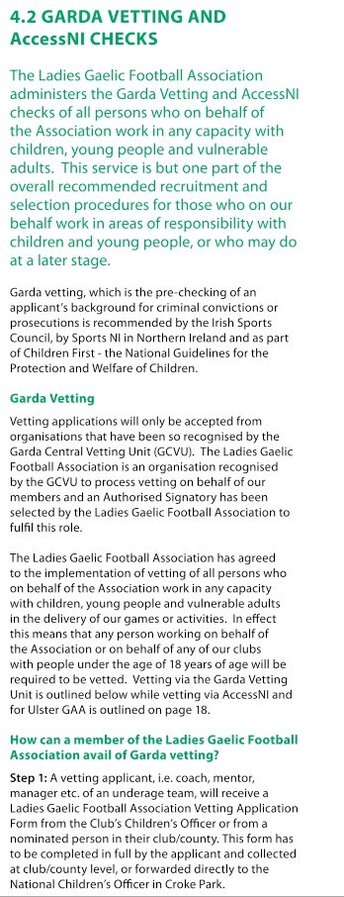
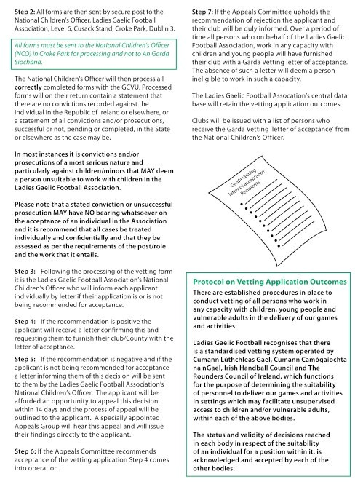

Our Games Our Code Code of Best Practice in Youth Sport
page 50

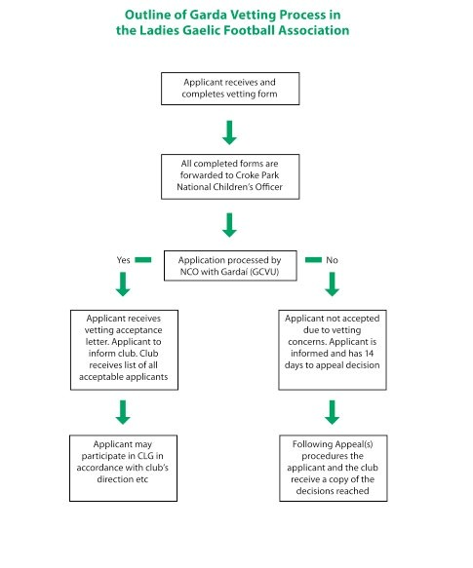

Our Games Our Code Code of Best Practice in Youth Sport
page 51

AccessNI
ADMINISTERED BY COMHAIRLE ULADH/ULSTER GAA FOR THE GAA,
LADIES GAELIC FOOTBALL ASSOCIATION, THE CAMOGIE ASSOCIATION, GAA HANDBALL IRELAND AND THE ROUNDERS COUNCIL OF IRELAND

Comhairle Uladh CLG (Ulster GAA) in complying with current child protection and welfare legislation and in accordance with Association guidance and policy have decided to take the necessary steps to ensure that anyone working with children or vulnerable adults at Provincial, County or Club level must be vetted. From the 1st April 2008 additional procedures came into operation for the vetting of personnel working with Children or Vulnerable Adults through ACCESSNI. Comhairle Uladh is now registered as an umbrella body with ACCESSNI, which allows us to carry out vetting checks.

WHAT IS ACCESSNI?

ACCESSNI is the vetting service which replaced the old POCVA service from the 1st April 2008. It provides criminal history information about anyone seeking paid or unpaid work in defined areas, such as working with Children or vulnerable adults and in our case for those that seek to work on our behalf with children or vulnerable adults in the GAA, with Handball, Rounders, Camogie and Ladies Gaelic Football,.

County Boards and Clubs are required to sign up to the Ulster Council terms and conditions for using the ACCESSNI vetting service before we can begin processing applications for checks on behalf of the county or club respectively.
Ulster GAA also acts as an umbrella body for then GAA, Handball, Rounders, Camogie and Ladies Gaelic
Football Association in processing vetting applications through ACCESSNI.

Details on this vetting process have been circulated to Clubs through our County Boards, however if
you require further information on this vetting process and the application forms Club Secretaries may
contact the Ulster Council Children’s Officer on 028/048 37521900 or by emailing info.ulster@gaa.ie

Ulster GAA also acts as an Umbrella Body for Handball, Rounders, Camogie and Ladies Football in processing vetting applications. These respective clubs again can avail of this service either by contacting their relevant Children’s Officer or by contacting the Ulster GAA.
Supervision

All clubs providing opportunities for our young people to participate in Gaelic games must ensure that all adults placed or appointed by them in roles of responsibility are suitable to fulfil such roles. All such persons must:
• Have had a recent Vetting (Garda/Police) check

• Have signed the Joint Code of Behaviour

• Have appropriate training and qualification to enable them fulfil their role

• Have an understanding of their responsibility to safeguarding children

• Have undertaken recognised Child Welfare Training as promoted by their Sport’s Governing Body

SUPERVISION RATIOS

Young people must always be adequately supervised regardless of activity and it is the responsibility of
Clubs to ensure that a satisfactory ratio of adults to young people is always maintained.

Supervision ratios will depend on the nature of the activity, the age of the players and any special needs of the group. It is recommended that a ratio of 1:8 for under 12 years of age and 1:10 for players over 12 years of age should be maintained as a basic minimum.

Such recommended ratios act as a guide and will vary depending on the circumstances, e.g. players with special needs, very young players, and mixed gender groups or on away trips.

PEOPLE ALLOCATED A SUPERVISORY ROLE SHOULD:

• Avoid being alone with any player, if you need to talk separately do so in an open environment, in view of others
• Not enter team dressing rooms unless deemed necessary by the team coach (es) so as to protect the privacy of other underage players and should always be accompanied by at least one other adult when in underage team dressing rooms.
• When organising a club trip always be mindful of ensuring that additional adults accompany the group in case of emergencies or unforeseen circumstances.
• When participating in an overnight stay a specific ratio of adults to children should have been agreed in advance. This ratio, which is very dependent on the age category of the children/young people, whether it is a single or mixed gender group and whether the group may be participating in certain outdoor activities or in water sports etc.
• Always clearly state start/finish times of training and if possible of games (home or away) and other
activities including trips away from home.

• Remain in pairs until players have been collected or have left in accordance with parental or guardian permission.
• Keep attendance records and record any injuries/incidents as they arise.

• All female underage teams must have at least one female acting in a supervisory capacity (e.g. Coach, Trainer). Similarly, all male teams must also have at least one male acting in a supervisory capacity,
Section 7
Communications and Social Media

Taking photographs of players, using web sites to publicise activities, contacting parents and guardians about training and games for underage teams the use of facebook and other social media networks in addition to the videoing of events, games, training and coaching sessions are normal daily activities
within most clubs. The Code of Best Practice in Youth Sport does not seek in any way to eliminate or curtail these activities but proposes certain safeguards so as to ensure that we minimise the risk or threats that inappropriate use of photographs or the recording of images may pose, particularly for young people.

Communicating with underage players and teams

Coaches and mentors should never place themselves in a compromising position by texting or communicating via social media sites with underage players. All such communications regarding GAA activities should be sent via the parents or guardians of the underage player, unless otherwise agreed with the parents/guardians, in writing.

In general the following should apply when communicating with underage players:

• Use mobile phones, if deemed appropriate, only via a group text or email system for communicating with the parents/guardians of players. Any exception to this form of group texting can only be proceeded with following permission from parents/guardians. (see Juvenile Membership Application form)
• Do not communicate individually by text/email sites with underage players.

• Do not engage in communications with underage players via social network sites.
Guidelines for Photographic/Recorded Images

It should be noted that having photographic and filming guidelines is not about preventing parents and guardians
from taking pictures, but rather to ensure that only those who have a right to take photographs do so.

These safeguards should still permit and facilitate the recording of relevant and suitable materials, should allow us to photograph the enjoyment gained by participating in our games, should enable coaches to
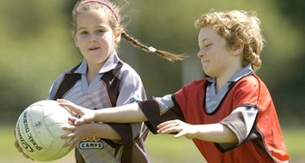
use the latest technology in the delivery of training skills and should also enable clubs to promote their activities in a safe and non threatening manner.

A common sense approach is required when deciding on what may or may not be appropriate as we do not wish to prohibit the recording of games, coaching sessions
or celebrations at club level through the use of photography or by recording on video equipment

The key concerns regarding the use of images
and photographs of children/young people relate to:
• The possible identification of children when a photograph is accompanied by personal information
and its inappropriate use thereafter

• The inappropriate use, adaptation or copying of images for use in child pornography or illegal website

• The taking of inappropriate photographs or recorded images of children

It should be noted that we have little or no influence on what photographs may be taken and published in local or national newspapers as such photography is covered by a different set of guidelines. Should we ever be unhappy with the publication of such photographs or images we can address this matter with the individual newspaper or the Press Council of Ireland and the Office of the Press Ombudsman.

Photography and the recording of images in a public place do not generally require explicit or prior consent. However if an event e.g. a game or training session is taking place, involving underage players, in a public, private or local authority park, and if you are in charge of such an event you are entitled to request a person to resist from taking photos if you feel that such action or photography may be inappropriate.

In general individual children should not be identified with the exception being when they are being publicly
acknowledged (e.g. an award or achievement), for which prior consent has been given.

Children and young people have a right to privacy and therefore their consent should be sought in relation to the use of personal data including images. Parental consent should also be sought and all clubs should receive signed permission from the player’s parents or guardians for the recording of photographic and recorded images etc as part of the player’s registration process. Information should also be provided as to how and for what purpose images will be used.

Be aware that refusal of consent should not in any way limit children or young people’s participation in activities.
BEST PRACTISE GUIDELINES:

• Ask for the player’s and parental permission to use their image. This consent could be included in the annual registration form.
• All children/young people featured in recordings must be appropriately dressed.

• The photograph or recording should focus on the activity rather than a particular young person.

• In general, no personal details relating to the young person should be revealed as accompanying materials to the photograph or recorded image, with the exception being where they are being publicly acknowledged (e.g. an award or personal achievement), for which consent has been given.
• Group and team photographs may be taken but it is not necessary to match a player’s name with the position in which they may be standing or seated in the team photograph. This is a precautionary recommendation based on previous examples of misuse of photographs by those who sought to exploit the gathering of young people together in an enjoyable and fun environment.
• Clubs, coaches and volunteers should be permitted to use video equipment as a legitimate coaching aid and as a means of recording special occasions; however, care should be taken in the dissemination, storage and use of such material.
• Parents and spectators taking photographs/recordings should where possible seek permission in advance from the Club/County Board and should also be prepared to identify themselves if requested and state the purpose for their photography/filming. If Club/County Board personnel are unhappy about any matter relating to such photography the permission granted should be withdrawn immediately.
• When commissioning professional photographers or inviting the press to a game or session ensure that they are clear about our expectations of them in relation to child protection.
• Any instances of the use of inappropriate images should be reported to the Club/County Board Children’s Officer and/or appropriate Designated Person and also to the relevant statutory authorities if deemed necessary.
Web Usage Guidelines

The world of social and digital media is an enjoyable and engaging place and is in itself a useful tool in promoting our clubs and activities within the membership and to a wider audience. As a vibrant organisation we should never shy away from using all forms of social media. But, we must be aware that while these communication tools can be used to our advantage vigilance is also required to ensure that our use of such communication methods must at all time be appropriate.

This Section of Our Games Our Code should be read in conjunction with the GAA Social Media Policies and Guidelines where more detailed information on the different forms of social media and their use is available.

A number of basic guidelines should be put in place when developing club web sites and social network sites eg Facebook, Twitter or LinkedIn etc. These guidelines should be adhered to at all times.

GENERAL WEB USAGE GUIDANCE:

• Agree to review the overall maintenance and upkeep of the web site at regular intervals.

• Appoint a web master to manage your web site on behalf of the club.

• Ensure that the web master is answerable to a member of the Club/County Board Management
Committee e.g. Chairperson, Secretary, PRO, etc.

• Decide at the outset what purpose your web site or social network page serves and include this in your content policy.
• All decisions on the appropriate use of photographic images and other similar content should be in accordance with the Guidelines for Photographic/Recorded Images.
• Agree if you will have a specific youth section and if so also agree the extent and the limitations on
its content etc.

• Consult with the Club/County Board Children’s Officer when designing the web site and agreeing
the usage policy and content material

• The web site or social network pages should at all times reflect the ethos of our Associations. Neither are platforms for personal opinion. They are a public representation of our games and should at all times be factual and follow the parameters of good behaviour.
• Agree a procedure in the club for dealing with any complaints or concerns that may be raised about the content of your web site or social network page.
• Agree to review the overall maintenance and upkeep of the web site at regular intervals.

WEB SITE CONTENTS POLICY

• The Club/County Board Website and its operator must make all reasonable attempts to insure that web pages are in keeping with the ethos of our Associations and do not contain any links to questionable material. Links to external websites are meant for convenience purposes only. No endorsement of any third party products or services should be expressed or implied by any information, material or content referred to or included on, or linked from the Club website.
• Agree a Club/County Board web site content policy, following discussions at your Club Management or Executive Committee and with members, including the underage members of the Club. This content policy will promote your strategy on the safe use of the Internet and
also outlines the parameters of behaviour and specifies the consequences of breaching those
parameters.

• Content published on web site or social network page should at all times be factual and follow the parameters of good behaviour.
• All decisions on the appropriate use of photographic images and other similar content should be in accordance with the Guidelines for Photographic/Recorded Images.
• Pictures of children/young people which display the name of the child/young person, or in any way link the name of a child/young person with his/her picture are not permitted except on the occasion of recognition for having received an award. Prior permission must be obtained, in keeping with photographic guidelines and if deemed appropriate only first or second name should be used.
• Content must be submitted for approval to the management committee or the appointed officer.

• Advocacy of or opposition to any politically or socially controversial subjects, issues, or candidates is prohibited.
• Disparagement or promotion of any person or class of persons is prohibited.

• Text, images, sound, or other presentations not suitable for people of all ages, or links to or other promotion of businesses whose products or services are not suitable for people of all ages is prohibited.
• Content that may be considered not to maintain the dignity and decorum appropriate for our
Associations is prohibited.
Social Media Guidelines

• Clubs/county Boards should only use an organisation page on social media.

• The page should only be used as a communications platform for the club.

• The page should be administered by at least two people appointed by and answerable to the Club/ County Board Executive Committee. The people appointed should be at ease with use of the social media and if possible comprise the PRO and/or Children’s Officer.
• The page should be checked on a daily basis.

• Posts which do not reflect the ethos of the organisation or could be misinterpreted should be
removed immediately.

GAA SOCIAL MEDIA POLICIES AND GUIDELINES

This document has been created to assist, educate and guide those who use social media in an official
GAA capacity.

SOCIAL MEDIA SETUP GUIDE

A step by step guide for setting when setting up on social media sites, specifically Facebook and Twitter
Section 8
Dealing with Allegations or Concerns of Abuse

The GAA, Ladies Gaelic Football Association, the Camogie Association, GAA Handball Ireland and the Rounders Council of Ireland all actively work in the promotion of our Games amongst young people and must be alert to the possibility that children with whom we are working may be suffering from abuse or neglect.

We all have a legal duty of care to children and young people. This means that we have an obligation to provide them with the highest possible standard of care in order to promote their well-being and safeguard them from abuse. Organisations are responsible for any failure to provide adequate care and safeguards for children in their care.

Additionally, should any member or employee of our Association be aware of any concerns or reports of abuse by or of an adult such matters should also be dealt with as matters of urgency through appropriate Club channels and in consultation with statutory authorities.
Guidance is available for members or employees on such matters from their relevant Designated Persons. Each of our Associations has signed up to the joint Code of Behaviour when working with underage players
(Section 3), and we have agreed procedures so as to facilitate our members in the Reporting of Allegations
of Abuse to statutory authorities. While additional and detailed guidance is given by each Association on reporting procedures in the event of concerns or allegations of abuse.

It is important that those who work on our behalf with underage teams and players are aware of the need to apply absolute confidentiality when dealing with all aspects of concern or allegations of abuse. This essentially means that information should only be shared with those that need to know such information in order to protect children or young people. This Section also outlines the definitions of abuse and the Role of the Designated Persons in our Associations.

Additional information on child abuse issues and on how to report allegations or concerns of abuse in your
Association are available from the three links below on page 65.
Confidentiality

It is important that all parties dealing with concerns of allegations of abuse have a clear understanding as
to what constitutes Confidentiality and what is permissible in the exchange of information.

• All information regarding concern or assessment of child abuse or neglect should be shared on ‘a need to know’ basis in the interests of the child
• No undertakings regarding secrecy can be given. Those working with a child and family should make this clear to all parties involved, although they can be assured that all information will be handled in a confidential manner taking full account of legal requirements.
• The provision of information to the statutory agencies for the protection of a child is not a breach
of confidentiality or data protection.

• It must be clearly understood that information gathered for one purpose must not be used for another without consulting the person who provided that information.
• All persons involved in a child protection and welfare process (the child, his/her parents/guardians,
the alleged offender, his/her family, coaches) should be afforded appropriate, fairness, support and confidentiality at all stages of the procedure
• Information should be stored in a secure place, with limited access only by the relevant Designated
Persons

• Breaches of confidentiality shall be deemed a serious matter and dealt with accordingly within the GAA, Ladies Gaelic Football Association, the Camogie Association, GAA Handball Ireland and the Rounders Council of Ireland
Role of the Designated Person

Every organisation, both public and private, that is providing services for children or that is in regular direct contact with children is required to:

Identify and appoint a Designated Person to act as a liaison with outside agencies and a resource person
to any staff member or volunteer who has child protection concerns.

The Designated Liaison Person is responsible for ensuring that the standard reporting procedure is followed, so that suspected cases of child neglect or abuse are referred promptly to Designated Officers in Statutory agencies, e.g. the HSE Children and Family Services or in the event of an emergency and the unavailability of the HSE, to An Garda Síochána and the Health and Social Care Trust’s Social Services Gateway Teams or the PSNI.

The Designated Liaison Persons should ensure that they are knowledgeable about child protection and on the necessary reporting procedures both within their own Associations and to statutory agencies. Designated Liaison Person are required to undertake any training considered necessary to keep themselves updated on new developments.

Due to the nature of our activity The GAA, Ladies Gaelic Football Association, the Camogie Association, Rounders Council of Ireland and GAA Handball Ireland recommend that all Clubs and County Boards should appoint a person who shall fulfil the role of Designated Person and who shall be responsible at an initial stage for dealing with any concerns relating to the possible abuse of children as reported or made known to them. On a national level we are obliged to appoint a person who on our behalf shall be the Association’s (National) Designated Person.

These appointments form an essential part of our Child Welfare and Protection strategy to ensure that in so far as is practically possible we provide a safe environment for children, young people and also for the adults who assist our underage members at Gaelic Games and other Association activities.

The GAA, Ladies Gaelic Football Association, the Camogie Association, Rounders Council of Ireland and GAA Handball Ireland are all committed to taking appropriate action where allegations or suspicions of abuse are made known to us and to sharing such information with the relevant statutory authorities in accordance with legislation and relevant guidelines.

In our work with children and young people we are directed by appropriate legislation within the jurisdiction in which we operate. Within each Association we have additional guidance on how to proceed with the reporting of allegations or concerns to the statutory authorities and to the relevant body within our Associations.

Designated Persons must have the ability to approach child welfare and protection matters in a sensible, balanced, facilitative and non threatening manner and shall be required to have good communication skills, shall be approachable and open minded and shall have indebt knowledge of their Association’s Guidelines. They are required to be fully aware as to their core responsibilities as to how they should deal with any allegations of abuse or suspicions of abuse that they may become aware of or are reported to them by members of the Association or by others.
When a Club or County appoints their Designated Person it is equally important to select a Deputy Designated Person who may in the absence of the Designated Person be called upon to fulfil this role. Relevant training should also be made available to both the Designated Persons at Club and County level and to the Deputy Designated Person so as to ensure they are familiar with their roles and responsibilities.
Recognising child neglect or abuse

The assistance provided by our Designated Persons in the area of recognising and reporting alleged child abuse is outlined in detail on our web sites. .

Child neglect or abuse can often be difficult to identify and may present in many forms. If a member, parent, coach or child has such concerns they may report such matter direct to the statutory authorities (e.g. HSE/Gardaí or Police/HSC Trusts NI) or may seek the assistance of their relevant Designated Person, who will assist them in making such reports. A list of indicators of child abuse is contained in Children First: National Guidance for the Protection and Welfare of Children. No one indicator should be seen as conclusive in itself of abuse. It may indicate conditions other than child abuse. All signs and symptoms must be examined in the context of the child’s situation and family circumstances.

GUIDELINES FOR RECOGNITION

The ability to recognise child abuse can depend as much on a person’s willingness to accept the possibility of its existence as it does on their knowledge and information. There are commonly three stages in the identification of child neglect or abuse:

• considering the possibility;

• looking out for signs of neglect or abuse;

• recording of information.

STAGE 1: CONSIDERING THE POSSIBILITY

The possibility of child abuse should be considered if a child appears to have suffered a suspicious injury for which no reasonable explanation can be offered. It should also be considered if the child seems distressed without obvious reason or displays persistent or new behavioural problems. The possibility of child abuse should also be considered if the child displays unusual or fearful responses
to parents/carers or older children. A pattern of ongoing neglect should also be considered even when
there are short periods of improvement.

STAGE 2: LOOKING OUT FOR SIGNS OF NEGLECT OR ABUSE

Signs of neglect or abuse can be physical, behavioural or developmental. They can exist in the relationships between children and parents/carers or between children and other family members/ other persons. A cluster or pattern of signs is more likely to be indicative of neglect or abuse. Children who are being abused may hint that they are being harmed and sometimes make direct disclosures. Disclosures should always be taken very seriously and should be acted upon, for example, by
informing the HSE/Gardaí or Police/HSC Trusts NI) either directly or through the relevant Club/County Designated Person. No child should not be interviewed in detail about alleged abuse without first consulting and seeking direction from the statutory authorities. Such contact with a child may be more appropriately carried out by the statutory authorities themselves.
SOME SIGNS ARE MORE INDICATIVE OF ABUSE THAN OTHERS. THESE INCLUDE:

• disclosure of abuse by a child or young person;

• age-inappropriate or abnormal sexual play or knowledge;

• specific injuries or patterns of injuries;

• absconding from home or a care situation;

• attempted suicide: for the Protection and Welfare of Children

• underage pregnancy or sexually transmitted disease;

• signs in one or more categories at the same time. For example, signs of developmental delay, physical injury and behavioural signs may together indicate a pattern of abuse.

Many signs of abuse are non-specific and must be considered in the child’s social and family context. It is
important to be open to alternative explanations for physical or behavioural signs of abuse.

STAGE 3: RECORDING OF INFORMATION

If neglect or abuse is suspected and acted upon, for example, by informing the HSE Children and Family Services, it is important to establish the grounds for concern by obtaining as much information as possible. Observations should be accurately recorded and should include dates, times, names, locations, context and any other information that may be relevant. Care should be taken as to how such information is stored and to whom it is made available. Advice on such issue may be obtained directly from statutory authorities or from the relevant Designated Person in our Associations.

CHILDREN WITH ADDITIONAL VULNERABILITIES

Certain children are more vulnerable to abuse than others. Such children include those with disabilities, children who are homeless and those who, for one reason or another, are separated from their parents or other family members and who depend on others for their care and protection. The same categories of abuse – neglect, emotional abuse, physical abuse and sexual abuse – are applicable, but may take
a slightly different form. For example, abuse may take the form of deprivation of basic rights, harsh
disciplinary regimes or the inappropriate use of medications or physical restraints.

(See definitions of Child Abuse Appendix 4)
Reporting allegations or concerns of abuse

GAA
Ladies Gaelic Football Association
Handball & Rounders
Camogie Association

REPORTING ALLEGATIONS OF CHILD ABUSE

GAA Handball & Rounders

Any member/employee of the Gaelic Athletic Association, who is informed, knows, suspects or is concerned that a child may be or may have been subject to child abuse, while engaged in Association activities or involving persons acting on behalf of the association, has a duty to convey such concerns as
a matter of urgency to the Designated Persons at Club, County, Provincial or National level in accordance with GAA procedures, as outlined elsewhere in these Guidelines.

Members of the GAA, in common with all other members of the public have a responsibility to report allegations of abuse directly to the statutory authorities. The GAA however is happy to facilitate our members in reporting these matters to the statutory authorities and have appointed Designated Persons at Club, County, Provincial and National level so as to assist this procedure.

Members/Employees of Cumann Lúthchleas Gael are furthermore obliged to facilitate and co-operate with any review or consideration of a complaint, report or allegation of abuse which may be carried out by statutory authorities or by the relevant Club, County or Provincial Designated Person or by the GAA National Child Welfare and Protection Committee.

It should be noted from the outset that when a report of abuse has been received all units and members of the Association are obliged to consider the following:

• The safety and welfare of the child must be of paramount concern to all members of the GAA. Any steps deemed necessary to protect the child should be implemented as a matter of urgency while also being careful that the person against whom the allegation has been made is not unreasonably penalised.
• All actions taken should be carefully considered by the Club and County Designated Person. Issues of debarment and reporting to statutory authorities should be considered in the strictest of confidence. The formal reporting of any allegation to statutory authorities and the issuing of a debarment order shall be made by the County Designated Person on behalf of Clubs within their
County or if necessary by the Provincial Designated Person (where applicable) or the GAA National
Designated Person.

• All matters concerning any allegation of abuse must be dealt with in strict confidence.

• The principle of natural justice must always be adhered to thus ensuring that the presumption of innocence applies until otherwise proven.
• When an allegation has been made and where reasonable grounds for concern have been established the matter shall be reported to the relevant authorities as a matter of urgency and to the relevant GAA Designated Person.
• The need to invoke the temporary debarment or standing aside of the person against whom an allegation has been made shall be done in a confidential manner, notwithstanding the urgency of the matter and the need to ensure that the welfare of the child is deemed to be of paramount importance.
• If an allegation of child abuse is received the statutory authority must be consulted before contact is made with the person against whom the allegation is made thus ensuring that any action by the GAA does not impact negatively on possible future external investigations.
• All reports made, whether internal or external to the GAA, shall note times, dates, locations etc. shall be signed by the person that raised the concern or made the allegation.
• Designated Persons shall accept reports on allegation or concerns of abuse from members or non members of the GAA verbally or in writing.
• Any reports or concerns regarding allegations of abuse once received by the Club/County Designated Liaison Person shall be recorded, signed, dated and where reasonable grounds for concern have been established shall be reported by the County Designated Person to the Statutory Authorities and to the GAA National Designated Person.
• Responses to and the reporting of allegations, reports or concerns of abuse to Club/County Designated Persons, to the Statutory Authorities and to the GAA National Designated Person (as appropriate) shall be carried as soon as possible and as a matter of priority.
• Additional information on the reporting allegations of abuse may be obtained in the GAA Guidelines for Dealing with Allegations of Abuse available on gaa.ie/clubzone.
REPORTING ALLEGATIONS OR CONCERNS OF ABUSE

Ladies Gaelic Football
*

5.2 DEALING WITH SUSPECTED " USE
5.2.1 Reporting abuse
5.2.2 Response to a young player
5.2.3 Allegation against Mentors
5.2.4 Steps within Organisation
5.2.5 False Reporting
5.2.6 Confidentiality
5.2.7 Anonymous Report
5.2.8 Rumours

Ab, t>
If there are grounds for concern (Appendix 6.4) about the safety or welfare of a young player you should react to the concern. If unsure about whether or not certain behaviours are abusive (Appendix 6.5) and therefore reportable, you should contact the duty social worker in the Local Health Soard or Social Services Department where you will receive advice. Grounds for concern Include a specific 1ndka11on from a player. a statement from a person who witnessed abuse or an illness. injury or behaviour consistent with abuse. Steps for reporting suspected abuse

(a) Observe and note dates, times. locations and contexts in which the incident occurred or suspicion was aroused, together with any other relevant information

(b) Report the matter as soon as possible to the designated officer within the Club/County responsible for reporting abuse, e.g. Children's Officer. If the Children's Officer has reasonable grounds for believing that the player has been abused or is at risk of abuse, s/he will make a report 10 the Health Board/Social Services who have statutory responsibility to investigate and assess suspected or actual child abuse
(c) In cases of emergency, where a player appears to be at immediate and serious risk and the Children's Officer is unable to contact a duty social worker,
the Garda Authorities should be contacted. Under no circumstances should a player be left in a dangerous situation pending intervention by the Statutory Authorities

(d) If the Children's Officer is unsure whether reasonable grounds for concern exist slhe can informally consult wilh the local health board/social services. Slhe will be advised whether or not the matter requires a formal report

Any Children's Officer reporting suspected or actual child abuse to the Statutory Authorities should first inform the family of their intention to make such a report unless doing so would endanger the player or undermine an investigation.

l .2 RHponse to• Young Player

Nhen • youny player d dos s nlormat,on of
Cl O

(a) Deal with any allegation of abuse in a sensitive and competent way through listening to and facilitating the player to tell about the problem, rather than interviewing about details of what happened

(bl Stay calm and not show any extreme reaction to what the player is saying. Listen compassionately, and take what the player Is saying seriously

(c) Understand that the player has decided to tell something very important and has taken a risk to do so. The experience of telling should be
a positive one so that the player will not mind talking to those involved in the investigation

(d) Be honest with the player and tell them that it is not possible 10 keep this information a secret

(e) Make no Judgmental statements against the person whom the allegation is made

(f) Not question the player unless the nature of what she is saying is unclear. Leading questions should be avoided. Open, non-specific questions should be used such as ·can you explain to me what you mean by that"

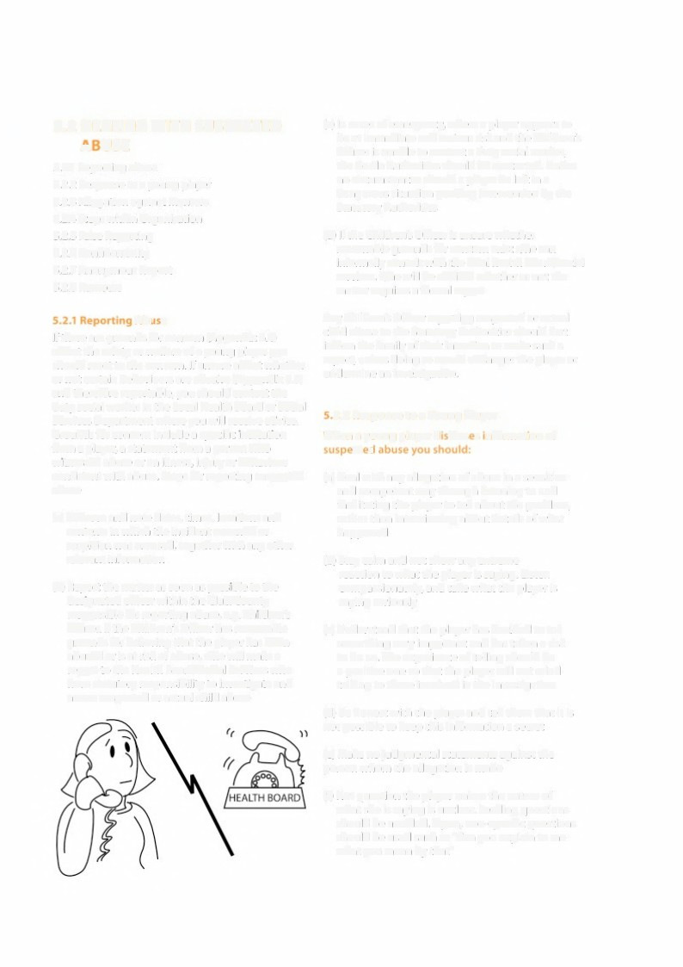
Our Games Our Code Code of Best Practice in Youth Sport
page 68

{g) Check out the concerns with the parents/ guardians before making a report uraess doing so would endanger the player

{h) Give the player some indication of what v.'OOld h.ippen next. such as informing parents/ gu<'lrdians, Health 8o<'lrd or Social Services, It shoold be kept in mind that the player may have been threatened and may feel vulnerable at this
stage

{i) ca,efully record the detail�

(j) Pa�s on this information to the Children's Officer/ designated officer within the Club, Alw<1ys reassure the pSayer that they have done the right thing in telling you

Always reassure the player that they have done the right thong on telling you"

S,l,3 All•gatlont Ag.,.i,at MtnlClrs
If an allegation of alleged chlld abuse Is made against a mentot working within the Club/County or Association, the following ptocedures should be followed:

The reporting procedu<e In respect of suspected
child abuse. (S.2.1)
The procedure for dealing with the mentoc
(S.2.4)

The safety of the player milki� the allegation should be considered and the safety of any other players who may be at risk. The dub should take
any necessary steps that may be necessary to protect its players. The issue of confidentiality is important - the mentor should be treated with respect and fairness.
5.2 .• Ou ling rith t"- M•ntor
Whi� the des.gnated 0.lldren·s Office( makes the rep0t1 to the lo(.al Htalth Board, ll"w: O.alrpetson of the club should deal with the reenter.

The Chairperson should privately h'lf0<m the mentOt tha1
Ca> an aneg,tniC)tl has bt,e,r\ made ag.ains1 hn'IV'her
(b) 1he natufe of lhe allt,gaoon

He/s.he should be afforded an opportunity to respond
His/her response should be noted and passed on lo the Health Board!Sod&I Services

The ment0< should be aske<t to step aside pendi"9 the outcome of the investtgauon. When a men10< Is asked 10 steo aside it should be mede
c�a< 1ha1 it Is only a pl'ec;au1ic,nary m.easure
and w\H net prejudice any tater disciplinary
1><0Geedin9s

The Clt)b/C()4)ntyChik;l,en's Officer should inform the Natt(l(lal Children's Officer tha1 the ment0< has been asked 10 stand aside.

11 ls also the du1Y of all Assoda.tlon members 10 lnfofm the Na1.ona1 Ch1ldien's Officer of a mentor who is und,e< lnvtS1iga1lon by a Statutory Avthot',ty.

The Ladies Gaelic Football AssC>Gla1,0n can consider d1sc1pUna<y a.<tt(l(I on 1he meotor but should ensure
1ha1 this does no1 Interfere with the i:nvestigation
ol tne S1a1u1ory Author'1tiies - the out<ome of the lnves1i9a11on and any ,mpllcations rt m.ght have wi1J be <onsidef'ed dm'u,91he Oisciptinary procedure.

11 shouk:I be noted 1ha11he faa 1hat me alleged abvser has nor Pf'O�uted or� found guitty
bee,,
does 001 eeau tha11hey are apptoprla1e to wort
whh young people in the fu11,1f'e.

5.3 False A legations

The Protection for Pefsons Reporting Chdd Abuse Act, 1998 provides immunity from dvtl lia.bility to persons who report child abuse ·reasonably and in good faith' to the Health Board or theGardal (See S.13.1 - ISC. Code>. The act al.so covers the offence of
'false reponiDg'.

The main provisions of the Act ace:

I. The provision of immunity (rom civil liability to any l)ff�on who reports child abu�e "reasonably and in
good faith" to desigMted officers of Health Boards or any member o( An Garda Siochina,

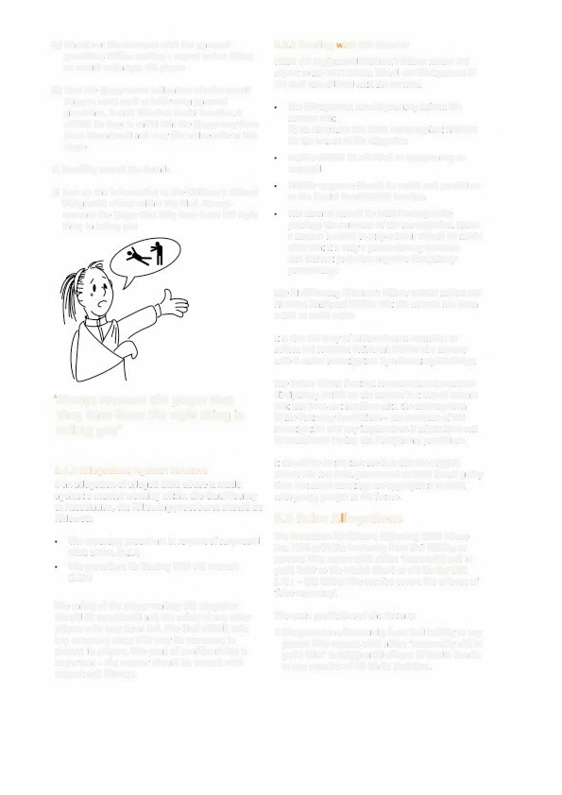
Our Games Our Code Code of Best Practice in Youth Sport
page 69

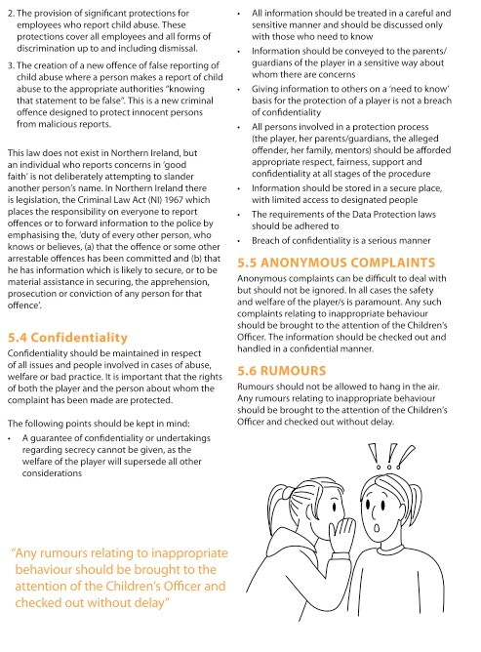

Our Games Our Code Code of Best Practice in Youth Sport
page 70

RESPONDING TO AND REPORTING ALLEGATIONS OR CONCERNS OF ABUSE

Camogie Association

Responding to a Disclosure or Allegation of Abuse

• Deal with any allegation of abuse in a sensitive and competent way through listening to and facilitating the child to tell about the problem, rather than interviewing the child about details of what happened.
• Stay calm and not show any extreme reaction to what the child is saying. Listen compassionately, and take what the child is saying seriously.
• Understand that the child has decided to tell something very important and has taken a risk to so do.
• The experience of telling should be a positive one so that the child will not mind talking to those involved in any subsequent investigation.
• Be honest with the child and tell them that it is not possible to keep the information a secret.

• Make no judgmental statements against the person whom the allegation is made.

• Do not question the child unless the nature of what s/he is saying is unclear. leading questions should be avoided. Open, non--specific questions should be used such as “Can you explain to me what you mean by that”.
• Check out the concerns with the parents/guardians before making a report unless doing so would endanger the child.
• Give the child some indication of what would happen next, such as informing parents/guardians, social services etc. It should be kept in mind that the child may have been threatened and may feel vulnerable at this stage.
• Carefully record the details.

• Pass on this information to the relevant Designated Person.

• Reassure the child that they have done the right thing in telling you.
REPORTING PROCEDURES

The following steps should be taken in reporting a concern or an alleged incident of child abuse to the statutory authorities:

• Observe and note dates, times, locations and contexts in which the incident occurred or suspicion was aroused, together with any other relevant information.
• Report the matter as soon as possible to the Designated Person with responsibility for reporting abuse. If the Designated Person has reasonable grounds for believing that the child has been abused or is at risk of abuse, s/he will make a report to the relevant statutory authorities who have statutory responsibility to investigate and assess suspected or actual child abuse.
• In cases of emergency, where a child appears to be at immediate and serious risk and the Designated Person is unable to contact a duty social worker, the Garda Síochána/PSNI should be contacted. Under no circumstances should a child be left in a dangerous or vulnerable situation pending intervention by the Statutory Authorities.
• If the Designated Person is unsure whether reasonable grounds for concern exist she/he can informally consult with the local social services or the County Designated Person.
• If the Designated Person, having consulted with the statutory authorities decides not to make a formal report s/he should inform the person making the original report of the decision and should provide that person with teh necessary information should they personally wish to pursue the matter with the relevant statutory authorities.
• The Designated Person should keep a record of all actions, decisions taken during the process.

• A Designated Person reporting suspected or actual child abuse to the Statutory Authorities should first inform the family of their intention to make such a, report, unless doing so would endanger the child or undermine an investigation
Section 9
Dealing with Bullying in your Club

Underage sports activity has a positive impact on the lives of thousands of young people many days of the week and every week of the year. The range of activities offered by the GAA, Camogie and Ladies Football Clubs and by our Handball and Rounders colleagues, to young people in particular, caters for more than their sporting needs.

The social and friendship aspects of meeting colleagues, the community ethos of our Associations and the general developmental opportunities that these surroundings present for young people, all contribute to the general well being of these young people, more often than not during some of the most developmental phases of their lives.

While sports organisations are recognised for the overall developmental opportunities they give to young people we are not immune to instances of behaviour that would be deemed as unacceptable and may in fact be deemed by us as breaches of our Code of Behaviour. A notable example of unacceptable behaviour that occurs in many walks of life is that of Bullying. Unfortunately, Bullying may occur in schools settings, in communities, in the work place or in sports organisations where a small cohort of people may choose to engage in Bullying behaviour.

HOW DO WE DEFINE BULLYING?

Bullying behaviour can be defined as repeated aggression be it verbal, psychological or physical,
conducted by an individual or group against others.

Our duty and our challenge as Club leaders, coaches or parents is to challenge such unacceptable behaviour and to put measures in place to counteract this behaviour. Our aim should be to:

• Understand Bullying and its possible impact within the context of our local Club

• Identify a range of approaches in relation to preventing Bullying

• Equip ourselves to deal with incidents of Bullying.

• Introduce and implement an Anti-Bullying Policy to our clubs

• Implement ‘a whole club approach’ to the issue of Bullying
ANTI BULLYING STATEMENT/POLICY

Each Club should adopt an Anti Bullying statement that could include the following:

“We aim to create a supportive environment where any form of Bullying is unacceptable.

We adopt ‘a whole organisational approach’ to addressing Bullying and are committed to implementing structures and relevant training to deal with allegations of Bullying. Incidents of Bullying are regarded as serious breaches of our Code of Behaviour and Code of Best Practice in Youth Sport.

We are committed to achieving an ethos of respect so as to maximise the potential of all our members when playing or participating in our Gaelic Games”.
(GAA Anti Bullying Statement 2012)

IT IS WIDELY ACCEPTED THAT BULLYING CONTAINS SEVEN KEY FEATURES:

• An intention to be hurtful

• This intention is carried out

• The behaviour harms the target

• The bully overwhelms the target with his/her power

• There is often no justification for the action

• The behaviour repeats itself again and again

• The bully derives a sense of satisfaction from hurting the target

Bullying can happen from any one person to another and from a young person to an adult or from an adult to a young person, from adults to adults and from a young person to a young person.

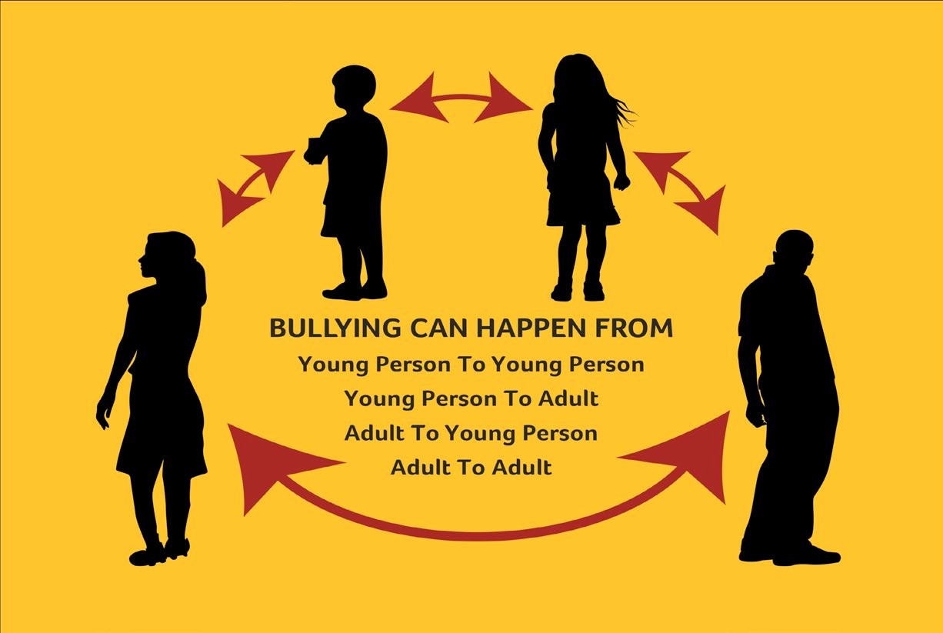
CYBERBULLYING can take place when instant messages, emails, text messages or webpages are used to spread rumours, make threats or harass. It can include written messages, photographs, videos or voice messages.
If you are a victim of Cyberbullying or believe you may be targeted by a Cyberbully you should:
• Sign off on your computer.

• Don’t respond or retaliate.

• Block the bully.

• Save and print out bullying messages.

• Talk to a friend.

• Tell a trusted adult.

HOW TO PREVENT BULLYING IN YOUR CLUB:

• Implement the joint Code of Behaviour when working with underage players which highlights good
practice and clarifies that instances of Bullying are deemed to be a breach of the Code.

• Create a supportive environment for all where it is not acceptable to Bully and highlight that the
Club has a ‘zero tolerance for Bullying’.

• The ethos of the club should be that it is ‘ok to tell’ the Club Children’s Officer or team coach of incidents of Bullying. Underage players should be made aware of the telling policy that ‘its ok to tell’ and they should be supported if they report any incidents of Bullying.
• Publicise the Club Anti-Bullying policy and display Anti Bullying Posters - available from the GAA.

• Ant Bullying is a ‘whole club responsibility’ and is part of the Give Respect Get Respect initiative. Its everybody’s responsibility.

WHAT DOES A WHOLE CLUB APPROACH INVOLVE?

• A recognition that Bullying can be tackled by all in the Club – Players, Coaches, Parents, Referees....

• Promoting policies and procedures which aim to prevent Bullying in the first instance and
intervene when appropriate.

• A shift from a problem based focus to a solution based focus.

• Creating a supportive environment where its ‘ok to tell’.

• An awareness and implementation of good practice in this area.

PROCEDURES FOR DEALING WITH BULLYING INVOLVING YOUNG PEOPLE/ADULTS

Incident should be dealt with as a breach of the Code of Behaviour as follows:
• Report the matter to the Club’s Children’s Officer.

• Confidentiality must be maintained.

• Initial assessment by the Club Children’s Officer.

• Children’s Officer collates relevant information.

• Club Children’s Officer uses the acid test to determine whether this is an incident of Bullying.

• Club Children’s Officer informs the alleged bully and target as to what procedures will follow.

Bullying is considered a breach of the Code of Behaviour and is dealt with as per the relevant section of the Code (see Code of Behaviour/ How to Deal with Alleged Breaches of the Code of Behaviour).
Section 10
Promoting a Healthy Club Programme

BACKGROUND

In recent years all of the Gaelic Games Associations have rolled out an increasing number of non-game specific programmes aimed at enhancing the lives and well-being of all our members and the wider community within which we operate.

The aim and purpose of this focus was manifold, but can be directly linked to a number of factors. These include:

• A desire to fulfil our ambitions as we continue to develop community-based volunteer led Clubs who promote Gaelic Games and that we also promote culture and lifelong participation thus ensuring that the GAA family and the values we promote enrich the lives of our members, our families and the communities we serve.
• An increasing demand from clubs for guidance and support on matters relating to the health and well-being of their members and players.
• An appreciation of the need to follow best practise in all related areas including drug and alcohol awareness, mental and physical health and well-being, suicide prevention and response, diet and nutritional advice, child and player welfare inclusion and integration and community engagement.

In the development of our proposals one such example of successful partnership and delivery at Club level has been the partnerships, between the GAA and the HSE, that resulted in the development of an Alcohol and Substance Abuse Prevention Programme that seeks to minimise the harm caused by the misuse of alcohol and other substances. This programme charges all units with appointing an ASAP officer and adopting a Club Drug & Alcohol policy. A sample policy, along with additional resources including a website (www.gaa.ie/asap), manual, DVD and promotional materials, were developed to assist clubs in rolling out the three key arms of the initiative: education, prevention and response.

On the basis of this development the concept of a expanding this programme into a ‘Healthy Club model’
has been explored.
HOW IT WILL WORK

A Healthy Club will be a club that promotes health and well-being amongst its members and the wider community. The framework for the Healthy Club has been broken down under the following pillars, offering clubs a structure that highlights existing areas of competencies while identifying new areas to target.
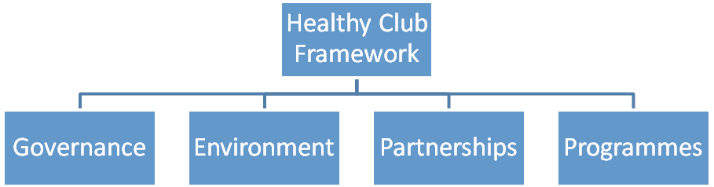

Participating clubs will be asked to form a ‘Healthy Club Committee’ – drawing membership from some/all of the following:

• ASAP Officer

• Children’s Officer

• Social Initiative representative

• Inclusion & Integration Officer

• Coaching Officer

• School Liaison Officer

• Player (adult and/or juvenile)

• Coach

• Parent

• Others with relevant skills set (e.g. those with an interest in health promotion/diet/nutrition/well- being etc)

THE COMMITTEE WILL BE REQUIRED TO:

• Conduct an audit and needs assessment of the club as it currently stands utilising the framework provided in the Healthy Club resource pack. This will identify the club’s existing strengths and weaknesses in relevant areas and will provide the club with a realistic starting point.
• Engage in a consultation process with club members and the wider community to inform the development and content of their Healthy Club model.
• Develop and adopt a Healthy Club Policy and oversee its implementation, with appropriate guidelines for developing a policy provided by the Healthy Club Steering Committee.
• Develop a sustainable Healthy Club Plan. The Healthy Club Plan will be specific to each club and, based on the initial audit, will outline what each club plans to do, where it intends to focus its attention each year, and will include timelines and frameworks for actions. The aim will be for each club to work proactively, having identified gaps in their existing structures/policies, and to target these in order of priority, rather than working reactively to specific incidents.
• Engage in an awareness campaign with club members and the wider community to promote the
Healthy Club and to garner support for fresh initiatives.
• Create and develop local partnerships (e.g. with HSE, Schools, Private Sector) to assist in and facilitate the roll-out and implementation of the Healthy Club programme.
• Facilitate evaluation of the Healthy Club programme through appropriate records and auditing of activities.

The over-riding aspiration of the Healthy Club programme is to benefit clubs and their members by ensuring all identified needs are covered under the four pillars of health and well-being outlined above governance; environment; partnerships; programmes). If a club identifies a specific need, e.g. in the area of governance or suicide prevention and response or increasing obesity levels, this can be worked towards through the provision of appropriate training and support both from within the Association and/or from local statutory or community organisations.

From the Association’s perspective as a whole, the programme should ensure best practice across this important area of its work as a sporting and cultural community organisation while also allowing for
a coherent management and implementation structure for the many health-related programmes it is already involved in including the ASAP programme, the Association’s Social Initiative, Inclusion & Integration and many more.
Section 11
Inclusion, Diversity and Integration in Sport

Sport is a universal language that should offer the opportunity for people to engage and connect with others regardless of cultural or ethnic origin, gender, age, sexual orientation or religious belief. It brings communities together and provides inspiration for others to promote and organise sporting activities.

The GAA, Rounders Council of Ireland, GAA Handball Ireland, Ladies Gaelic Football Association and the Camogie Association Inclusion and Integration Strategy launched in 2009, seeks to “offer an inclusive and welcoming environment for everyone to participate in our Games and Culture”.

Our aspiration is to be in a position by 2016 to state that:

‘We have an outstanding reputation for attracting and retaining members in all our sports from all sections of the community. We welcome people of all nationalities, ethnicities, religions, ages and abilities into our sports and we make it easy for everybody to take part. We champion equality within the Irish sporting landscape and communities overseas. We work with the GAA family to make sure that we offer
an inclusive and welcoming environment for everyone’.

As with any strategy it is important to ensure that our members and the general public understand what we mean when we state that we wish to aspire to the principles of “Inclusion”, “Diversity” and “Integration”.

Inclusion essentially means people having a sense of belonging, of being comfortable in being part of what they value. Diversity means being aware of, accommodating and celebrating difference. Integration in this instance; means the integration of the family of Gaelic Games i.e., the GAA, the Rounders Council
of Ireland, GAA Handball Ireland, the Ladies Gaelic Football Association and the Camogie Association

Inclusion and Diversity in many ways go hand-in-hand. Real inclusion reflects diversity, i.e. it aims to offer that sense of belonging to everyone, irrespective of gender, marital status, family status, sexual orientation, religion, age, race or membership of the Traveller community and/or disability.

INCLUSION

Gaelic Games have been at the heart of communities throughout Ireland for over 125 years. They have never been solely about sport or recreation. They have been about building a sense of community and identity, at both local and national levels.
In more recent times our Gaelic Games’ Associations have sought to positively include people with disabilities in our Games. These efforts include Wheelchair Hurling/Camogie, Adapted Football and Blind Rounders. ‘Have-a-Go/International Days’ which give members of Minority Ethnic communities a chance to try out various Gaelic Games’ activities. Equality and Disability Awareness Training have been delivered to GAA, the Rounders Council of Ireland, GAA Handball Ireland, the Ladies Gaelic Football Association and the Camogie Association personnel while the Give Respect – Get Respect Initiative at Senior Intercounty matches clearly reflect the message that our Associations understand our responsibility in recognising
and promoting diversity on the island of Ireland.

DIVERSITY

We have always had diversity in Ireland and in the recent decade that diversity has become
more varied and complex. Diversity is a positive enriching source of vitality and growth, but it can also be
a source of conflict and hurt. Many differences such as language, ethnicity, and social class are linked, as are parallel issues such as identity, educational attainment and the ability to participate fully in the economic, social, cultural and sporting landscape within society.

Why is it important that Gaelic Games reflect the diverse Ireland that we live in today?

• Our Clubs are there to serve their community and many are the hub of the community

• Our Associations are inclusive organisations

• It’s the right thing to do

INTEGRATION

The Integration of the family of Gaelic Games has been in operation in Ulster since 2002 with the aim of giving a shared focus to the development and promotion of all Gaelic Games and Culture. The GAA, the Rounders Council of Ireland, GAA Handball Ireland, the Ladies Gaelic Football Association and the Camogie Association are working at national level to develop an integration strategy that will focus on co-operation in various areas such as coaching, games development, public relations, marketing, club governance, youth development, refereeing and strategic planning.

Integration is not just about assimilation, it is about co-operation. Each organisation and sporting code will keep their identity, while working together on a broad range of issues to enhance the promotion of Gaelic Games.

WHY INTEGRATE?

The integration process draws together the resources and talent of the five organisations and assist all
codes in developing their games, thus increasing grassroots participation.

In the last few years Inclusion & Integration Committees have been established at Provincial and County level with representatives from the GAA, the Rounders Council of Ireland, GAA Handball Ireland, the Ladies Gaelic Football Association and the Camogie Association working together to advance and promote meaningful integration.
It is the intension that Integration will:
• Create a ‘family’ focus in all associations

• Create a new focus in coaching and games development

• Enhance club development

• Better promote the health and wellbeing agenda

• Promote equality

• Bring a holistic approach to the future direction of Gaelic Games

The establishment in recent years of Inclusion & Integration Committees at both Provincial and County with representatives from Ladies Gaelic Football and Camogie alongside their colleagues from Football, Hurling, Handball and Rounders will assist us in directing our work so that we may state by 2016 that:

‘We have an outstanding reputation for attracting and retaining members in all our sports from all sections of the community. We welcome people of all nationalities, ethnicities, religions, ages and abilities into our sports and we make it easy for everybody to take part. We champion equality within the Irish sporting landscape and communities overseas. We work with the GAA family to make sure that we offer
an inclusive and welcoming environment for everyone’.
Section 12
Player Injury Schemes

GAA Injury Scheme
Ladies Gaelic Football Injury Fund
Camogie Association Personal Accident Scheme

GAA Injury Scheme

This is a mandatory scheme and provides benefit to members playing the national games of Hurling, Gaelic Football, Handball and Rounders whose clubs are registered with the scheme and to accredited club personnel performing designated duties in connection with the activities of Clubs registered in the Scheme. The GAA Injury Scheme does not seek to compensate fully for injury but to supplement other Schemes. Ultimately, the responsibility to ensure that adequate cover is in place lies with the individual member, commensurate with his specific needs.

THE SCHEME APPLIES TO:

• Players on a team registered with the Scheme who incur accidental injury while playing Hurling, Gaelic Football, Handball or Rounders only, either:
(a) in the course of an official competitive game or a challenge game or
(b) in the course of an official and supervised team training session.

• Match officials i.e. referees, linesmen or umpires injured whilst officiating at an official game of
Hurling, Handball, Gaelic Football or Rounders as specified in Rule 1.1

• Voluntary coaches, team managers, selectors and members of official team parties injured during games or training as specified in Rule 1.1
• Members performing designated duties under request/instruction of an authorised Club Officer, in
a strictly voluntary capacity, on GAA property or on property under the exclusive use of the GAA.

• The scheme covers Adult and Youth members of the GAA and, also, players registered with the
Scheme through Primary, Post-Primary and Third-level Schools and Colleges and Inter-Firm Units

• For the purpose of the Scheme, an Adult is a Full Registered member of the GAA who was 18 years of age or over on registration of his team(s) with the Scheme.
• A Youth is a Youth member of the GAA who was under 18 years of age on registration of his team(s)
with the Scheme.
LIFETIME DISABILITY BENEFIT (PAYABLE IN ADDITION TO ANY OTHER BENEFIT) €300,000

A single identifiable occurrence on the field of play resulting in permanent total physical paralysis such that the Insured Person is confined to a wheelchair for life.

Capital Benefits
• Permanent Total Disablement from gainful employment €100,000

• Loss of Sight €100,000

• Permanent Partial Loss of Sight Up to €100,000

• Loss of Limb(s) €100,000

• Complete and incurable paralysis €100,000

All above benefits Less any Loss of Wages Benefit claimed

Permanent Partial Disablement (“Continental Scale”)
A scale of benefits providing for benefits to a maximum of €50,000 for specified disabilities applies.
Details are available on request.

Death Benefit
• Adult (or Married Youth) €50,000

• Youth €25,000

(iii) Medical
Otherwise unrecoverable medical expenses up to a maximum of €4,500. The first €100 of each and every
claim is not covered.

(iv) Dental
Otherwise unrecoverable dental expenses up to a maximum of €4,500. The first €100 of each and every
claim is not covered.

(v) Supplementary Hospital Benefit
€400 per day’s stay in hospital. Benefit only payable If stay is a minimum of 10 consecutive days up to a
maximum of 15 days

(vi) Loss of Wages (Applicable (a) to Adults and (b) to Youths who are in full-time employments at the date of injury)
Otherwise unrecoverable loss of basic nett wages (i.e. excluding overtime, bonuses, unsociable working
hours etc.) payable up to 52 weeks but excluding the first week

Social Welfare/Income Protection and/or other entitlements will be considered as recoverable
income and will be deducted from the basic nett wage figure.
Benefit is payable for full weeks only and the maximum benefit payable per week is as follows:

WEEK 1 NIL

WEEKS 2-4 UP TO €200

WEEKS 5-52 UP TO €400

(vii) Benefits/Conditions and Team Subscriptions may be altered from time to time at the discretion of C.L.G.

NOTE: The injury scheme is funded entirely from Club and GAA funds with no outside (e.g. insurance) involvement. There is no legal obligation on the GAA to provide such a scheme. Risk is an inherent factor in sport, as in life. When members voluntarily take part in Club Activities, they accept the risks that such participation may bring. Legal representation is not required and there is strictly no Legal Expenses Cover amongst the benefits provided.
For information purposes only. It does not form any contract and does not purport to deal with all aspects of the GAA Injury Scheme.
Ladies Gaelic Football Injury Fund

WHAT IS THE INJURY FUND?

The injury fund is an injury scheme and NOT an insurance scheme and does not seek to compensate fully for injury, rather to lessen the hardship to players and officials. The fund should supplement other schemes where applicable, i.e. VHI, Vivas, Quinn, etc.

WHO DOES THE INJURY FUND COVER?

The Injury Fund covers those in the fund for injuries sustained in the following:
a) an official competitive or challenge game b) an official and supervised training session
It also applies to Club Officers, Team Mentors and Match Officials (Referees, Umpires and Linespersons)if
registered to the injury fund. All players must be registered to the fund.

HOW IS THE INJURY FUND FUNDED?

• Fund is solely funded by subscriptions

• The subscription to the Fund shall be determined by Central Council.

Present Rates are:
Adult: | €25
Under-Age Player: | €10
U-10 Player: | €5

An adult player paying €25 will be entitled to be considered for payment of wages or salary lost together with medical expenses.
An under-age player paying €10/ €5 will be entitled to be considered for payment of medical expenses only

WHAT ARE THE BENEFITS OF THE SCHEME?

Dental
• Unrecoverable dental expenses up to a maximum of €3000

Medical
• Unrecoverable medical expenses up to a maximum of €5000

• Physiotherapy sessions shall be limited to a maximum of 6 sessions. If subsequent sessions are required a full report must be submitted by the registered chartered physiotherapist or physical therapist. Further payment will only be considered on receipt of this report. Physiotherapy is required to be carried out by individuals with an appropriate third level qualification, who are members of a regulatory professional body in line with their qualifications and who have appropriate insurance/ indemnity.
• Travel expenses and any medical aids are not covered under the scheme
Loss of Wages
• Applicable to both adult and underage players who are in employment and who have paid the €25 subscription
• Unrecoverable loss of basic wages are payable for a maximum of 20 weeks. The maximum benefit
payable per week amounts to €200

• An underage player in full or part time employment should pay the adult rate as this would allow the player to claim loss of wages

ARE THERE ANY EXCLUSIONS FROM THE INJURY FUND?

The scheme shall not apply in the case of a player/official:
• Who is injured during a game as a result of an assault wherein the claimant has been the aggressor

• Whose injury arises from a pre-existing physical defect or infirmity or from the use of alcohol or
drugs

• Who may be pregnant, suffering from concussion etc. Any player who plays in this condition is
entirely responsible for any consequences that may arise

In the event of an application made by any member which is not a bona fide application, and which is made for the purposes of obtaining payment to which they are not entitled, the application shall be declared void. Suspensions may arise as a result to all parties involved

WHAT IS THE PROCEDURE FOR MAKING A CLAIM?

• A Co-ordinator, based in Head Office, (Rosemarie Coyle) is employed to co-ordinate the day to day
running of the fund on behalf of Central Council.

• The National Treasurer of the Association will liaise with the Co-ordinator on a regular basis

• All submissions of claims must be made within two months of the date of injury to Head Office

• Where a claim cannot be made within the two month period, or the claim may exceed €200 a
Preliminary Notification Form (1-page form) should be completed and forwarded to Head Office

• All forms are available from Clubs, County Boards or Head Office.

• Claim forms should be signed by the injured player and counter signed by the Club Secretary
as a declaration of authenticity. This is then forwarded to the County Secretary and signed as a
declaration that s/he has been officially notified of the injury

WHAT DOCUMENTATION NEEDS TO BE FORWARDED WITH THE CLAIM?

The claim documentation must incorporate:
• Loss of Wages Claims: Employer’s Certification stating the basic loss of earnings along with the last
four payslips

• The official in charge of the team must sign the claim

• A letter from the appropriate Secretary as to whether permission had been granted for a challenge match should the injury have occurred during this match
• Original receipts must be forwarded. No photocopies will be accepted

• If the applicant has suffered from a previous injury and has already received payment from the
Injury Fund, the reference number from that claim should be included on the claim form
WHAT IS THE PROCEDURE IF A PLAYER REQUIRES PRIVATE TREATMENT?

Private treatment is defined as any treatment that is paid outside of the public health treatment system Any request for private treatment must be supported by documentation from a Medical Practitioner to show reasons why private treatment is necessary
• Private Treatment involves a step by step procedure

• Permission to see a Consultant – send Doctors letter to Head Office

• Permission for a MRI scan – send consultant letter to Head Office

• Permission for surgery – send results of MRI and consultant letter to Head Office

• If a submitted claim is not fully documented, the necessary documents may be requested by the
Coordinator, or declared void

• All payments are made directly to the applicant

• Where claims are late being received by Central Council, and if the delay is due to the Club or
County Board, then the Club or County Board can be held responsible for the payment of the claim

WHAT ARE THE MAIN GUIDELINES FOR PLAYERS?

• Report any suspected injury

• When completing the Application Form, print your name, address and club clearly under Section 1

• Ensure permission is sought for private treatment

• A copy of all forms, receipts, letters, etc sent should be kept and any correspondence received should also be kept
• Where a preliminary claim has been submitted, a report and update on the claim must be submitted within one year from the date of the preliminary notice to validate the claim
• All claims for which preliminary notices have been received must be lodged and validated within two years of the original preliminary notice except in exceptional circumstances
• Injury claims will be monitored on a claim by claim basis and a player who plays while receiving treatment may have her claim disallowed

WHAT ARE THE KEY GUIDELINES FOR OFFICIALS?

• Ensure all details on form are completed and in order prior to forwarding claim

• Ensure forms are forwarded on time

• Ensure a plentiful supply of all forms are available and accessible for all players

• Establish a register of claims for your own records
Camogie Association Personal Accident Scheme

Willis is delighted to offer you our Camogie Personal Accident Scheme product offering. Please download
the following summary cover documents for full details of the cover provided:
• Cumann Camógaíochta Euro Summary of Cover 2012

• Cumann Camógaíochta Sterling Summary of Cover 2012

We can confirm the premium for 2012 including the Government Levy is:
• €17 \ £17 per adult registered playing member non transferable (18 years of age at the date of application of the insurance \ renewal date and over)
• €7 \ £7 per youth registered playing member non transferable (under 18 years of age at the date of application \ renewal date for the insurance)

Cover is effective for 12 months. Please note that these premiums are a reduction on last years of €18 \
€8. You will note that the main benefits have increased even though we are charging a reduced premium
and the government levy has increased since January 1st 2012.

The key changes to the 2012 Camogie Personal Accident Scheme can be summarised as follows:

• Loss of Wages – First two weeks are not covered, weeks 3 – 104 - €500.00 \ £500.00 maximum per week – previously only covered up to 52 weeks
• Medical Expenses \ Dental Expenses - €10,000.00 \ £10,000.00 – (previously €7,500.00 \
£7,500.00)

• Hospital Confinement - €20.00 \ £20.00 per day up to a maximum of 90 days hospitalised – this benefit is new for 2012

Medical Expenses \ Dental expenses excess remains unchanged at €75.00 \ £75.00 for adult claimants. For youth claimant’s, the excess has been reduced to €50.00 \ £50.00, it previously was €75.00 \ £75.00. If the claimant is only claiming physiotherapy expenses, the excess is 10% of the claim subject to a minimum excess of €75.00 \ £75.00 for both adults and youths.

Following a review of the Personal Accident Scheme renewal procedures and in particular the role of the club officer responsible for administrating the scheme, we wish to advise you that there is now no requirement to provide us with a copy of your club registration forms showing the names, addresses and dates of birth of your club members requiring cover.

To reduce the administration on the Scheme and to make it easier and more efficient for you to administer, all you have to do is to advise us of the number of adult registered playing members and the number of youth registered playing members requiring cover together with your remittance payable by cheque to Willis Risk Services (Ireland) Ltd. For example, if you would like to insure 20 adult registered playing members and 40 youth registered playing members, all you to need to advise us of these numbers and make a cheque payable to Willis Risk Services (Ireland) Ltd in the amount of €620.00 \ £620.00 (20 x
€17.00 \ £17.00 + 40 x €7.00 \ £7.00).
However, in the event that one of your registered playing members submits a claim to us, we will ask you at that stage for a copy of your registration forms to confirm that the registered member was an insured member at the time of the claim. Therefore, as the designated club officer, you are responsible for keeping a record of the members registered under the Scheme and a copy of the registration forms must be available when requested by us. In the event of a claim, please download the following claim forms:
• Cumann Camógaíochta Euro 2012 Claim Form

• Cumann Camógaíochta Sterling 2012 Claim Form

If your members are in any doubt as to why they should take the Camogie Personal Accident cover, please download the following case testimonials which demonstrate the importance of having cover in the event of an injury sustained while playing Camogie
• Camogie Case Testimonials

If you have any queries on the above or the attached documents, please do not hesitate in contacting our team by email at gaa.queries@willis.ie or by telephoning our helpline on 01 639 6343

Willis Risk Services (Ireland) Ltd (t\a Willis) is regulated by the Central Bank of Ireland
Section 14
Appendices
Juvenile Membership Application Form

Please complete this form in full and return to your Child’s Team Manager/Coach or your Club’s Children’s Officer. The completion of this form is essential so as to enable your child participate in all Gaelic Games, training and other related activities in your club.

SECTION 1

I as Parent/Guardian of
(child) give permission for the named, to participate in (Club name) games and other related activities

Child’s Name: Address:

Parent/Guardian contact telephone number/s: Parent/Guardian email address:
Emergency contact person (if you are unavailable): Telephone number:

SECTION 2

Details of Child’s special needs or medical history (i.e. details of any known allergies, conditions or medications). Parents/Guardians are obliged to disclose any information regarding medication which may impact on your child’s welfare or behaviour while participating in our sports:
In the event of illness or injury, I give permission for medical treatment to be administered where considered necessary by a nominated first aider, or by suitably qualified medical practitioners. If I cannot be contacted and my child needs emergency hospital treatment, I authorise a qualified medical practitioner to provide emergency treatment or medication

YES NO

SECTION 3

Photography:
I agree that photographs or recorded images may be taken during or at sport related activities, which may include my Child and may subsequently be used in the promotion of our Games.

YES NO

SECTION 4

I wish for my Club/County to use group text messaging relating to the participation of my son/daughter in relation to Club/County game’s activity. I wish for such texts messages to be sent to:

Myself only Text contact number: My child and myself Text contact numbers:

SECTION 5

Declaration

I have read and accept the rules and procedures as set down in the Code of Best Practice in Youth Sport, Our Games Our Code.

Signature of Parent/Guardian:

Date:
Coach and Mentor Application Form

Surname: Forename: Previous name (if any):
Address: Email:
Home telephone number: Mobile number: Role applied for?

Have you submitted a vetting form in accordance with Association procedures? YES NO

Please outline why you wish to become involved in our club?

Please give details of any previous involvement in sports including coaching experience and relevant
qualifications:

Do you suffer from any illness or medical condition which may at times affect your ability to work with
young people in this role? Is so, please give details:
Have you ever been asked to terminate your involvement in any Sporting or Community Organisation?
(If yes we will contact you in confidence):
YES NO

Please supply the name, address, and a contact telephone number of two people (non-relative), who from personal knowledge are willing to support your application. If you have a previous involvement in a sports organisation one of these two named person (below) should be from that sports organisation

Name 1: Name 2: Address: Address:

Tel No: Tel No:

Professional Relationship with Referee: Professional Relationship with Referee

Declaration:
• I confirm that nothing within my personal or professional background may deem me unsuitable for
a position which involves working with children/young people in sport.

• I declare that the above information is true and agree to abide by ‘OUR GAMES - OUR CODE, Code of Best Practice in Youth Sport when working with underage players
• I agree to abide by the Rules of the Association.

Signed:

Date:

This form should be returned to and retained by the Club Secretary or Registrar.

For Club use only
Checked by phone Visit Letter Checked by: Date: Signed:
Incident/Accident Reporting Form

This form should be used for each occasion of

• Accidental fall/injury

• Aggressive behaviour

• Verbal abuse

• Destruction of equipment or property (or threats of )

• Physical assault (or threats of )

Name of person completing this form: Role/Position of person completing this form: Signature of person completing this form: Date:

INCIDENT/ACCIDENT

Date and time of incident:

Name/s of person/s involved in the incident and their clubs/associations:

What activity was taking place when the incident occurred?

Witnesses (include contact details):
REPORTING OF THE INCIDENT TO CLUB/ASSOCIATION

Incident Reported to: Date:
How was the incident/accident reported? e.g. using this form, in person, email, phone..

FOLLOW UP ACTION

Description of actions to be taken:

Club/Association notes only:
Definitions of Child Abuse

In the first instance it is important that we are aware of the definitions of abuse and to be in a position to recognise incidents of such abuse. Child abuse can be categorised into four different types: neglect, emotional abuse, physical abuse and sexual abuse. A child may be subjected to one or more forms of abuse at any given time.

It should be noted that the definition of Neglect, Emotional Abuse, Physical Abuse and Child Sexual Abuse presented in this section are not present as legal definitions.

It is also important to recognise that extreme incidents of Bullying may also constitute abuse - see Section
9: Dealing with Bullying in your Club

For the purpose of this Code of Best Practice in Youth Sport and in common with legislation in many of the jurisdictions in which we operate ‘a child’ means a person under the age of 18 years, excluding a person who is or has been married.

DEFINITION OF NEGLECT

Neglect can be defined in terms of an omission, where the child suffers significant harm or impairment of development by being deprived of food, clothing, warmth, hygiene, intellectual stimulation, supervision and safety, attachment to and affection from adults, and/or medical care.
Harm can be defined as the ill-treatment or the impairment of the health or development of a child. Whether it is significant is determined by the child’s health and development as compared to that which could reasonably be expected of a child of a similar age.

Neglect generally becomes apparent in different ways over a period of time rather than at one specific point. For example, a child who suffers a series of minor injuries may not be having his or her needs met in terms of necessary supervision and safety. A child whose height and weight is significantly below average may be deprived of adequate nutrition.
A child who consistently misses school may be being deprived of intellectual stimulation.

The threshold of significant harm is reached when the child’s needs are neglected to the extent that his or her well-being and/or development are severely affected.
DEFINITION OF EMOTIONAL ABUSE

Emotional abuse is normally to be found in the relationship between a parent/carer and a child rather than in a specific event or pattern of events. It occurs when a child’s developmental need for affection, approval, consistency and security are not met. Unless other forms of abuse are present, it is rarely manifested in terms of physical signs and symptoms. Examples may include:
• The imposition of negative attributes on a child, expressed by persistent criticism, sarcasm, hostility or blaming;
• Conditional parenting in which the level of care shown to a child is made contingent on his or her behaviours or actions;
• Emotional unavailability of the child’s parent/carer;

• Unresponsiveness of the parent/carer and/or inconsistent or inappropriate expectations of the child;

• Premature imposition of responsibility on the child;

• Unrealistic or inappropriate expectations of the child’s capacity to understand something or to behave and control himself in a certain way;
• Under- or over-protection of the child;

• Failure to show interest in, or provide age-appropriate opportunities for, the child’s cognitive and emotional development;
• Use of unreasonable or over-harsh disciplinary measures;

• Exposure to domestic violence;

• Exposure to inappropriate or abusive material through new technology.

Emotional abuse can be manifested in terms of the child’s behavioural, cognitive, affective or physical functioning. Examples of these include insecure attachment, unhappiness, low self-esteem, educational and developmental underachievement, and oppositional behaviour. The threshold of significant harm is reached when abusive interactions dominate and become typical of the relationship between the child and the parent/carer.

DEFINITION OF PHYSICAL ABUSE

Physical abuse of a child is that which results in actual or potential physical harm from an interaction, or lack of interaction, which is reasonably within the control of a parent or person in a position of responsibility, power or trust. There may be single or repeated incidents.
Physical abuse can involve:
• Severe physical punishment;

• Beating, slapping, hitting or kicking;

• Pushing, shaking or throwing;

• Pinching, biting, choking or hair pulling;

• Terrorising with threats;

• Observing violence;

• Use of excessive force in handling;

• Deliberate poisoning;

• Suffocation;

• Fabricated/induced illness (see Appendix 1 for details);

• Allowing or creating a substantial risk or significant harm to a child.
DEFINITION OF CHILD SEXUAL ABUSE

Child Sexual Abuse occurs when a child is used by another person for his or her gratification or sexual
arousal, or for that of others. Examples of child abuse include:

• Exposure of the sexual organs or any sexual act intentionally performed in the presence of the child;
• Intentional touching or molesting of the body of a child whether by a person or object for the
purpose of sexual arousal or gratification;

• Masturbation in the presence of the child or the involvement of the child in an act of masturbation;

• Sexual intercourse with the child, whether oral, vaginal or anal;

• Sexual exploitation of a child, which includes inciting, encouraging, propositioning, requiring or permitting a child to solicit for, or to engage in, prostitution or other sexual acts. Sexual exploitation also occurs when a child is involved in the exhibition, modelling or posing for the purpose of sexual gratification or sexual act, including its recording (on film, video tape or other media) or the manipulation, for those purposes, of the image by computer or other means. It may also include showing sexually explicit material to children, which is often a feature of the
‘grooming’ process by perpetrators of abuse;

• Consensual sexual activity involving an adult and an underage person. In relation to child sexual abuse, it should be noted that, for the purposes of the criminal law, the age of consent to sexual intercourse is 17 years for both girls and boys. An Garda Síochána will deal with the criminal aspects of the case under the relevant legislation.
It should be noted that the definition of child sexual abuse presented in this section is not a legal definition and is not intended to be a description of the criminal offence of sexual assault.
National Contacts for HSE Children and Family Services

Also listed on HSE website (www.hse.ie/go/socialworkers) and from HSE LoCall Tel. 1850 241850. These contact numbers may be updated from time to time. Please check HSE website for latest information.
HSE Area Address Telephone
National Contacts for HSE Children and Family Services

Appendix 2: National contacts for HSE Children and Family Services

Also listed on HSE website (www.hse.ie/go/socialworkers) and from HSE LoCall Tel. 1850 241850. These contact numbers may be updated from time to time. Please check HSE website for latest information.

HSE Area | Address | Telephone No.
DUBLIN NORTH | Health Centre, Cromcastle, Coolock, Dublin 5 | (01) 816 4200 (01) 816 4244
DUBLIN NORTH CENTRAL | Social Work Office, 22 Mountjoy Square, Dublin 1  Social Work Office, Ballymun Health Centre, Dublin 11 | (01) 877 2300  (01) 846 7236
DUBLIN NORTH WEST | Health Centre, Wellmount Park, Finglas, Dublin 11  Social Work Department, Rathdown Road, Dublin 7 | (01) 856 7704  (01) 882 5000
DUBLIN SOUTH EAST | Social Work Department, Vergemount Hall, Clonskeagh, Dublin 6 | (01) 268 0320 (01) 2680333
DUBLIN SOUTH CITY | Duty Social Work Carnegie Centre, 21-25 Lord Edward Street, Dublin 2  Public Health Nursing, 21-25 Lord Edward Street, Dublin 2  Family Support Service, 78B Church House, Donore Avenue, Dublin 8 | (01) 648 6555 (01) 648 6730  (01) 416 4441
DUBLIN SOUTH WEST | Milbrook Lawn, Tallaght, Dublin 24 | (01) 452 0666 (01) 427 5000
DUBLIN WEST | Social Work Department, Bridge House, Cherry Orchard Hospital, Ballyfermot, Dublin 10 | (01) 620 6387
DUBLIN SOUTH | Social Work Department, Our Lady’s Clinic, Patrick Street, Dun Laoghaire, Co. Dublin | (01) 663 7300
CARLOW | Carlow Social Work Office, Ground Floor, St. Dympna’s Hospital, Athy Road, Co. Carlow | (059) 913 6587
CAVAN | HSE Community Child and Family Services, Drumalee Cross, Co. Cavan | (049) 437 7305 (049) 437 7306
CLARE | Clare Duty Social Worker, River House, Gort Road, Ennis, Co. Clare  Social Work Department, Shannon Health Centre, Shannon, Co. Clare  Social Work Department, Kilrush Health Centre, Kilrush, Co. Clare | (065) 686 3935  (Mon – Fri, 2pm - 5pm) (061) 718 400  (065) 905 4200
CORK | North Cork Social Work Department, 134 Bank Place, Mallow, Co. Cork  North Lee Child Lee Social Work Department, (adjacent to Shopping Centre), Blackpool, Co. Cork  South Lee Social Work Department, St. Finbarr’s Hospital, Douglas Road, Cork  West Cork Social Work Department, Coolnagarrane, Skibbereen, Co. Cork | (022) 54100 (021) 492 7000  (021) 492 3001 (028) 40447
DONEGAL | Links Business Centre, Lisfannon, Buncrana, Co. Donegal (East Team) Euro House, Killybegs Road, Donegal, Co. Donegal (West Team)  Social Work Department, Millennium Court, Pearse Road, Letterkenny, Co. Donegal (East Central Team and West Central Team) | (074) 932 0420 (074) 972 3540  (074) 912 3672 (074) 912 3770
GALWAY | Galway City, Social Work Department, Local Health Office, 25 Newcastle Road, Galway, Co. Galway  Galway County, Tuam Social Work Department, Health Centre, Vicar Street, Tuam, Co. Galway  Loughrea Social Work Department, Health Centre, Loughrea, Co. Galway  Ballinasloe Social Work Department, Health Centre, Brackernagh, Ballinasloe, Co. Galway  Oughterard Social Work Department, Health Centre, Oughterard, Co. Galway | (091) 546366 (093) 37200  (091) 847820 (090) 964 6200  (091) 552200

75
National Contacts for HSE Children and Family Services
Children First: National Guidance for the Protection
and Welfare of Children

KERRY | Social Work Department, HSE Community Services, Rathass, Tralee, Co. Kerry  Killarney Social Work Department, St. Margaret’s Road, Killarney, Co. Kerry | (066) 712 1566  (064) 663 6030
KILDARE | Social Work Department, St Mary’s Craddockstown Road, Naas, Co. Kildare | (045) 873200 (045) 882 400
KILKENNY | Social Work Office – Child Care Department, Child Youth and Families, Carlow/Kilkenny, HSE South, St. Canice’s Hospital, Dublin Road, Kilkenny, Co. Kilkenny | (056) 778 4057 (056) 778 4532
LIMERICK | Social Work Department, Ballynanty Health Centre, Ballynanty, Limerick  (East Team), Co. Limerick  Social Work Department Roxtown Health Centre, Roxtown Terrace, Old Clare  Street, Limerick (East Team) , Co. Limerick  Parkbeg Social Work Department, Parkbeg House, 2 Elm Drive, Caherdavin  Lawns, Ennis Road, Limerick, Co. Limerick  Social Work Department, Southill Health Centre, O’Malley Park, Southill, Limerick, Co. Limerick  Newcastlewest Social Work Department, Newcastlewest Health Centre, Newcastle West, Co. Limerick. | (061) 457 100  (061) 417 622 (061) 483 091  (061) 206 820 (061) 209 985  (069) 62155
LAOIS | Social Work Department, Child and Family Centre, Portlaoise, Co. Laois | (057) 869 2567 (057) 869 2568
LEITRIM | Social Work Department, Community Care Office, Leitrim Road, Carrick on Shannon, Co. Leitrim | (071) 965 0324
LONGFORD | Social Work Department, Tivoli House, Dublin Road, Co. Longford | (043) 335 0584
LOUTH | Social Work Department, Local Health Care Unit, Wilton House, Stapleton  Place, Dundalk, Co. Louth  Ballsgrove Health Centre, Ballsgrove, Drogheda, Co. Louth | (042) 939 2200  (041) 983 8574 (041) 983 3163
MAYO | Ballina Social Work Team, Ballina Health Centre, Mercy Road, Ballina, Co. Mayo  Castlebar Social Work Team, St. Mary’s Headquarters, Castlebar, Co. Mayo  Swinford Social Work Team, Swinford Health Centre, Aras Attracta, Swinford, Co. Mayo | (096) 21511 (096) 248 41  (094) 902 2283 (094) 905 0133
MEATH | Community Social Work Services, Enterprise Centre, Navan, Co. Meath  Community Social Work Services, Child and Family Centre, Navan, Co. Meath  Community Social Work Services, Dunshaughlin Health Care Unit, Dunshaughlin, Co. Meath | (046) 909 7817 (046) 907 8830 (01) 802 4102
MONAGHAN | Social Work Department, Local Health Care Unit, Rooskey, Co. Monaghan | (047) 30426 (047) 30427
OFFALY | Social Work Department, Derry Suite, Castlebuildings, Tara Street, Tullamore, Co. Offaly | (057) 937 0700
ROSCOMMON | Social Work Team, Abbeytown House, Abbey Street, Roscommon, Co. Roscommon  Social Work Team, Roscommon PCCC, Lanesboro’ Road, Roscommon, Co. Roscommon (Roscommon Area)  Social Work Team, Health Centre, Elphin Street, Boyle, Co. Roscommon  (Boyle Area)  Social Work Team, New HSE Offices, Knockroe, Castlerea, Co. Roscommon  (Castlerea Area) | (090) 662 6732  (090) 663 7528 (090) 663 7529  (071) 966 2087  (090) 663 7851 (090) 663 7842

76
National Contacts for HSE Children and Family Services
Appendix 2: National contacts for HSE Children and Family Services

SLIGO | Sligo Town and surrounding areas: Markievicz House, Barrack Street, Sligo, Co. Sligo  South County Sligo: One Stop Shop, Teach Laighne, Humbert Street, Tubercurry, Co. Sligo | (071) 915 5133  (071) 912 0062
NORTH TIPPERARY | North Tipperary Duty Social Work Team, Civic Offices, Limerick Road, Nenagh, Co. Tipperary  North Tipperary Child Protection Services: Social Work Department, Annbrook, Nenagh, Co. Tipperary  St. Mary’s Health Centre, Parnell Street, Thurles, Co. Tipperary | (067) 46 636 (067) 41 934  (0504) 24 609
SOUTH TIPPERARY | South Tipperary Child Protection Services: Social Work Team, South Tipperary  Community Care Services, Western Road, Clonmel, Co. Tipperary | (052) 617 7302 (052) 617 7303
WATERFORD | Waterford: Social Work Service, Waterford Community Services, Cork Road, Co. Waterford  Dungarvan and surrounding areas: Social Work Department, Dungarvan  Community Services, St. Joseph’s Hospital, Dungarvan, Co. Waterford | (051) 842827  (058) 20906
WESTMEATH | Social Work Department, Athlone Health Centre, Coosan Road, Athlone, Co. Westmeath  Social Work Department, Child and Family Centre, St. Loman’s, Springfield, Mullingar, Co. Westmeath | (090) 648 3106  (044) 934 4877
WEXFORD | Gorey Health Centre, Hospital Grounds, Gorey, Co. Wexford Enniscorthy Health Centre, Millpark Road, Enniscorthy, Co. Wexford New Ross Health Centre, Hospital Grounds, New Ross, Co. Wexford  Social Work Department, Ely House, Ferrybank, Co. Wexford | (053) 943 0100 (053) 923 3465  Contact through  Ely House below  (053) 912 3522 Ext. 201
WICKLOW | Social Work Department, HSE Glenside Road, Wicklow Town, Co. Wicklow  Bray: Social Work Department, The Civic Centre, Main Street, Bray, Co. Wicklow  Delgany: Social Work Department, Delgany Health Centre, Delgany, Co. Wicklow | (0404) 60800  (01) 274 4180 (01) 274 4100  (01) 287 1482

77
Standard Report Form
For reporting child protection and/or welfare concerns to the HSE

Appendix 3: STANDARD REPORT FORM
for reporting child protection and/or welfare concerns to the HSE

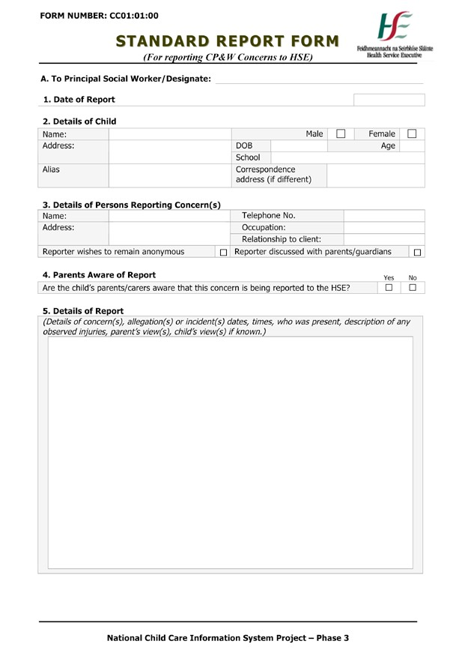

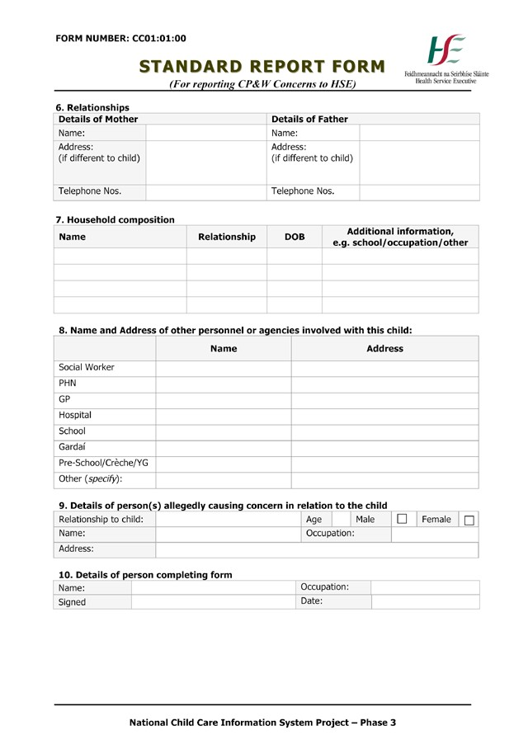

Our Games Our Code Code of Best Practice in Youth Sport
page 105

Health and Social Care Trusts NI

Health and Social Care Trusts provide health and social care services to the public and all such services are provided locally and on a regional basis

Each Health and Social Care Trust provides a Gateway Service. This is the social work service for children and families and is the first point of contact for people who are concerned about a child or young person. It provides an immediate response to safeguard children in need of protection.

Gateway social workers visit children, young people and their families in their own homes to assess their needs. Social workers liaise with other professionals involved with the family to ensure their views are included in the assessment.

If you contact the Gateway Team by phone, the Duty Worker will firstly seek some general information about you, the child or family and the nature of your concern. On the basis of this information they will be able to judge whether or not the enquiry should be progressed to referral.

BELFAST HEALTH AND SOCIAL CARE TRUST GATEWAY SERVICES/CHILD PROTECTION



How to access the Service
Anyone can contact this service directly in one of the following ways:

By phone:
During office hours (9.00am – 5:00pm) - you should contact Gateway on 028 9050 7000
At all other times (all through the night, at weekends and over Bank Holidays) - you should contact the out-of-hours Emergency Service: 028 9056 5444

In person:
Speak to a Duty Social Worker at
Gateway Services
110 Saintfield Road
BELFAST BT8 6HD
NORTHERN HEALTH AND SOCIAL CARE TRUST GATEWAY SERVICES



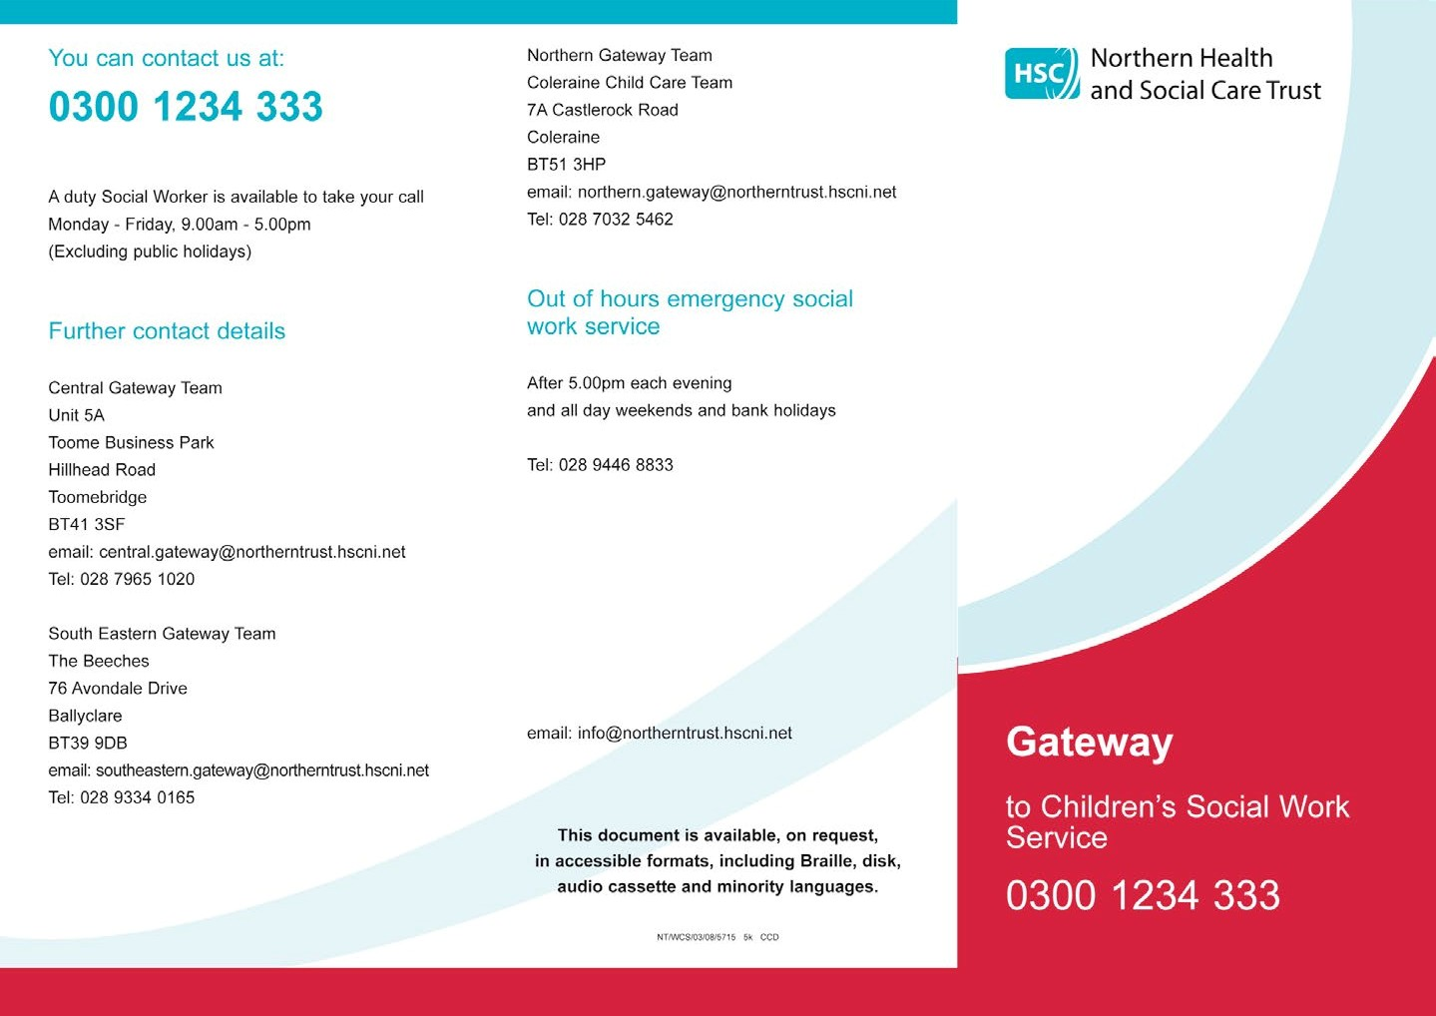

SOUTH EASTERN HEALTH AND SOCIAL CARE TRUST GATEWAY SERVICES



The South Eastern Health and Social Care Trust is an amalgamation of the former Ulster Community & Hospitals Trust and Down Lisburn Trust and will encompass the government districts of Newtownards, Down, North Down and Lisburn. The Trust is an integrated organisation and thus provides a mix of both acute hospital services and community health & social services.

0300 1000 300
A duty Social Worker is available to take your call Monday - Friday, 9.00am - 5.00pm
(excluding public and bank holidays)Fu

Details
Out of Hours Emergency
Social Work Service
Phone (028) 9056 5444 after 5.00pm each evening at weekends and Public/Bank Holidays

SOUTHERN HEALTH AND SOCIAL CARE TRUSTS

The Southern Trust provides health and social services care for those people living in the Armagh, Banbridge, Craigavon, Dungannon and Newry and Mource council areas.
Southern College of Nursing
Craigavon Area Hospital
68 Lurgan Road Portadown BT63 5QQ
Tel: 028 3833 4444

Southern Health and Social Care Trusts Child Protection / Gateway Service
The Gateway Service for Children’s Social Work is the first point of contact for people who wish to share a
concern about a young person who is not already known to social services.
The central telephone number for all new referrals or information about the service is 028 3741 5285. In addition, there is also a freephone number 0800 783 7745 (free from landlines only).
The service ensures a quick response to the needs of children and families who are referred for a Social Work Service. A Duty Social Worker is available to take calls from Monday to Friday from 9am-5pm (excluding Public Holidays).

WESTERN TRUST HEADQUARTERS



MDEC Building
Altnagelvin Area Hospital site
Glenshane Road Londonderry BT47 6SB
Tel: 028 7134 5171

What areas do we cover?
The Western Trust Gateway Team can be contacted for help in the Derry, Limavady, Strabane, Omagh and
Enniskillen areas by calling the following centralised number: 028 7131 4090

The Gateway team has three bases:
• Derry Office - Whitehill, 106 Irish Street, Derry - Londonderry BT47 2ND

• Omagh Office -Tyrone & Fermanagh Hospital, Omagh, Co Tyrone BT79 0NS

• Enniskillen Office - 2 Coleshill Road, Enniskillen, Co Fermanagh BT74 7HG
GAA Social Media Policies and Guidelines

This document has been created to assist, educate and guide those who use social media in an official
GAA capacity.

These guidelines will evolve over time as new technology and platforms emerge. They currently deal with the social media world as it is today, and keep a few basic aims for the GAA in mind:
• To promote and develop positive online discussion of the GAA

• To protect the reputation of official GAA social media platforms online

• To help moderate discussions appropriately

To ensure the GAA provides an official voice in this area

GAA Social Media Setup Guide

The GAA’s online presence is made up of a network of individuals, operating websites and social media channels at club and county levels. For this reason, a common set of GAA Social Media Guidelines and Policies have been put in place so that all units within the Association are working in unison as one GAA family.

To complement these guidelines, this setup guide has been
produced to assist units in best practice when setting up on social networks. It is by no means an exhaustive guide; as the number of social networks continues to grow, the guide will be revised and updated regularly to help us all in the GAA.
Contact details

GAA, Ladies Gaelic Football Association, Camogie Association, Rounders Council of Ireland and GAA Handball Ireland

Cumann Lúthchleas Gael
(The Gaelic Athletic Association) Tel: +353 (0) 1 836 3222
Páirc an Chrócaigh/Croke Park, Dublin 3 Email: info@gaa.ie http://www.gaa.ie

Cumann Camógaíochta
(The Camogie Association) Tel: + 353 (0)1 865 8651
Páirc an Chrócaigh/Croke Park, Dublin 3 Email: info@camogie.ie http://www.camogie.i

Cumann Peil Gael na mBan
(The Ladies Gaelic Football Association) Tel: +353 (0) 1 836 3156
Páirc an Chrócaigh/Croke Park, Dublin 3 Email: info@ladiesgaelic.ie http://www.ladiesgaelic.ie

Comhairle Liathróid Láimhe na hÉireann
(GAA Handball Ireland) Tel: +353 (0) 8192385
Páirc an Chrócaigh/Croke Park, Dublin 3 Email: nationalmanager.handball@gaa.ie http://wwwgaahandball.ie

Comhairle Cluiche Corr na hÉireann
(The Rounders Council of Ireland) Tel: + 353 (0) 87 7523003
c/o Joe O’ Donoghue, Ballinadrum, Ballon, Email: secretary.rounders@gaa.ie
Co. Carlow http://www.gaarounders.ie

